FOOTPATH INSPECTION REPORT
PARISH |  | Spurstow | FOOTPATH |  |  | FP1
FROM |  | Back Lane (Nursery Lane) rear of Panama Hatty’s | TO Direction of Peckforton
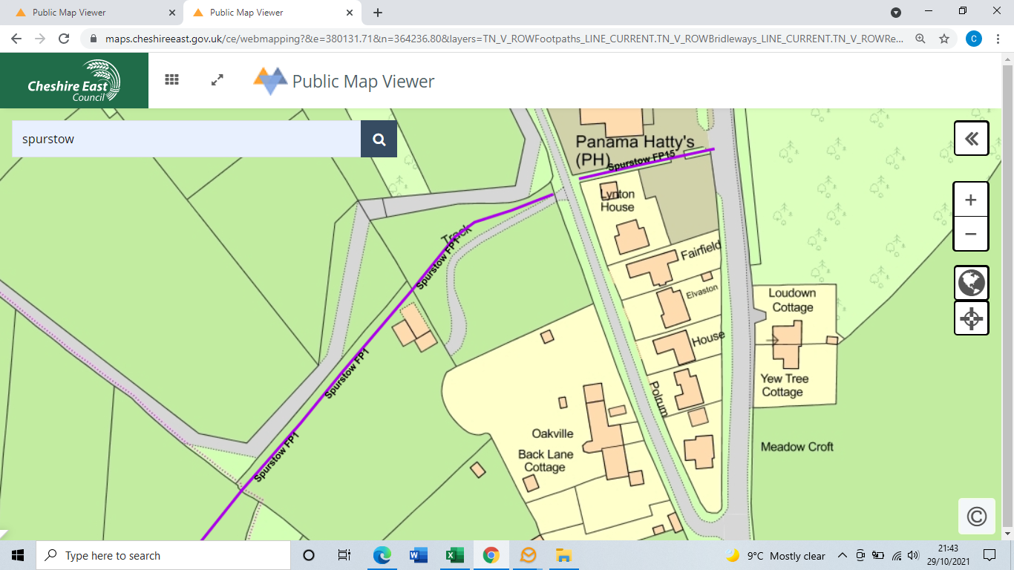
COMMENTS

INSPECTOR |  |  |  | DATE

