FOOTPATH INSPECTION REPORT
PARISH |  | Spurstow | FOOTPATH |  |  | FP10
FROM |  | North of Pear Tree Cottage on Long Lane | TO |  |  | Footpath 11 near Cappers Lane via Brindley Hall Lane
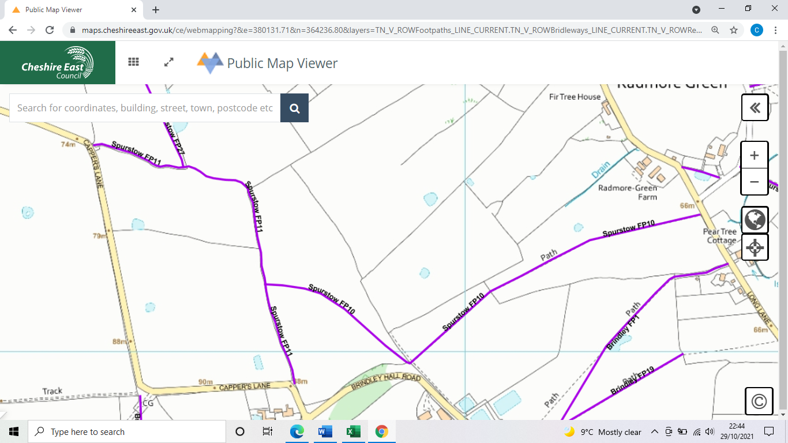
COMMENTS

INSPECTOR |  |  |  | DATE

