FOOTPATH INSPECTION REPORT
PARISH |  | Spurstow | FOOTPATH |  |  | FP11
FROM |  | Near Ryders Bank Cottage on Cappers Lane | TO |  |  | North and then West to corner on Cappers Lane
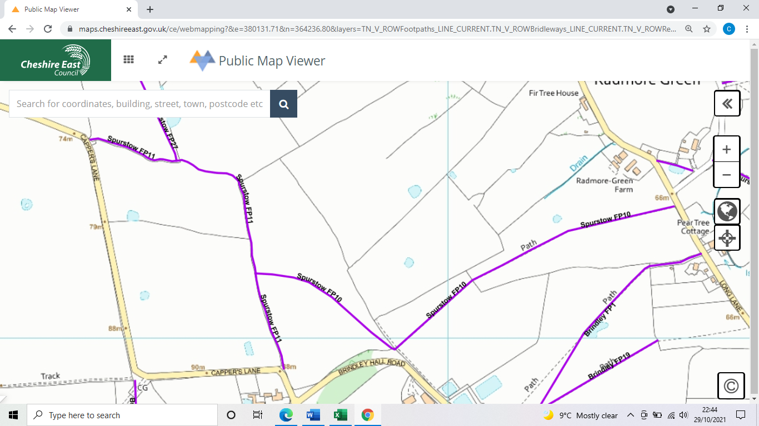
COMMENTS

INSPECTOR |  |  |  | DATE

