FOOTPATH INSPECTION REPORT
PARISH |  | Spurstow | FOOTPATH |  |  | FP12
FROM |  | Just North of Spawood Farm on Cappers Lane | TO |  |  | South West to meet Footpath 13 at the edge of Spa Plantation
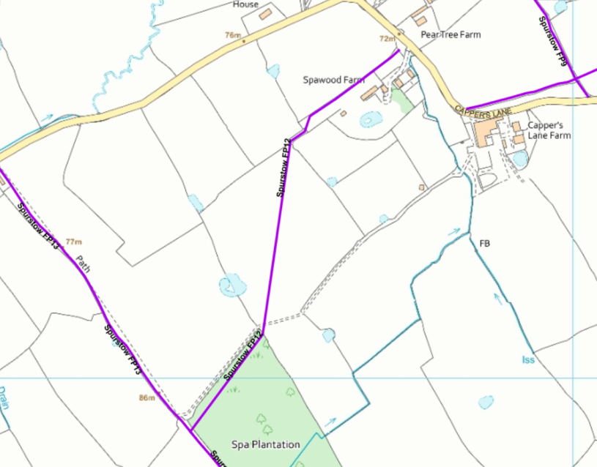
COMMENTS

INSPECTOR |  |  |  | DATE

