FOOTPATH INSPECTION REPORT
PARISH |  | Spurstow | FOOTPATH |  |  | FP13
FROM |  | Just East of Bath House, South East past Spa Plantation | TO |  |  | South East to meet Brindley Footpath 5 near High Ash Farm
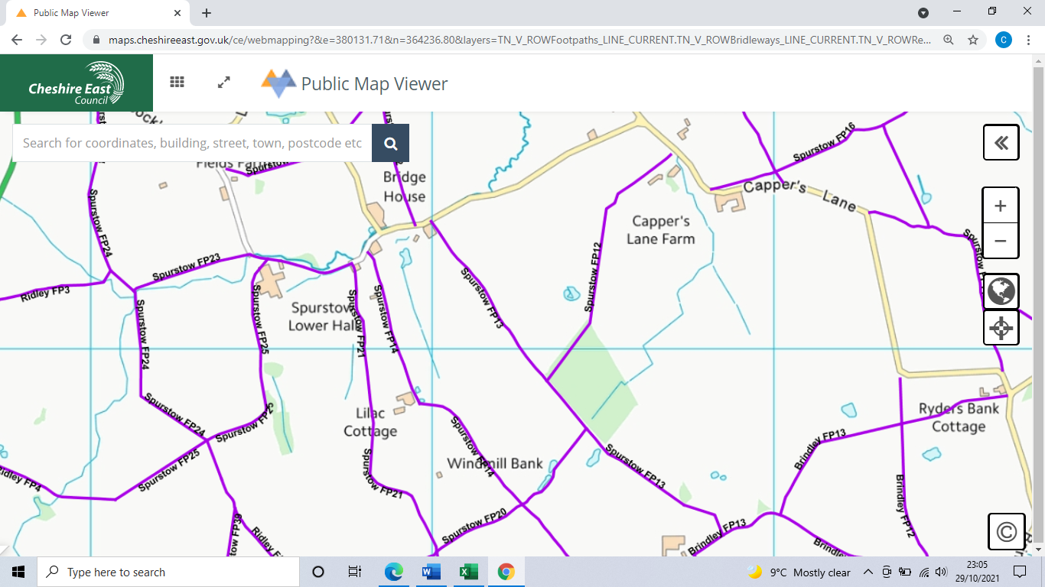
COMMENTS

INSPECTOR

