FOOTPATH INSPECTION REPORT
PARISH | Spurstow | FOOTPATH | FP14
FROM | Just West of Coxey Green, Bathwood Lane | TO | South East via Lilac Cottage to near High Ash Farm
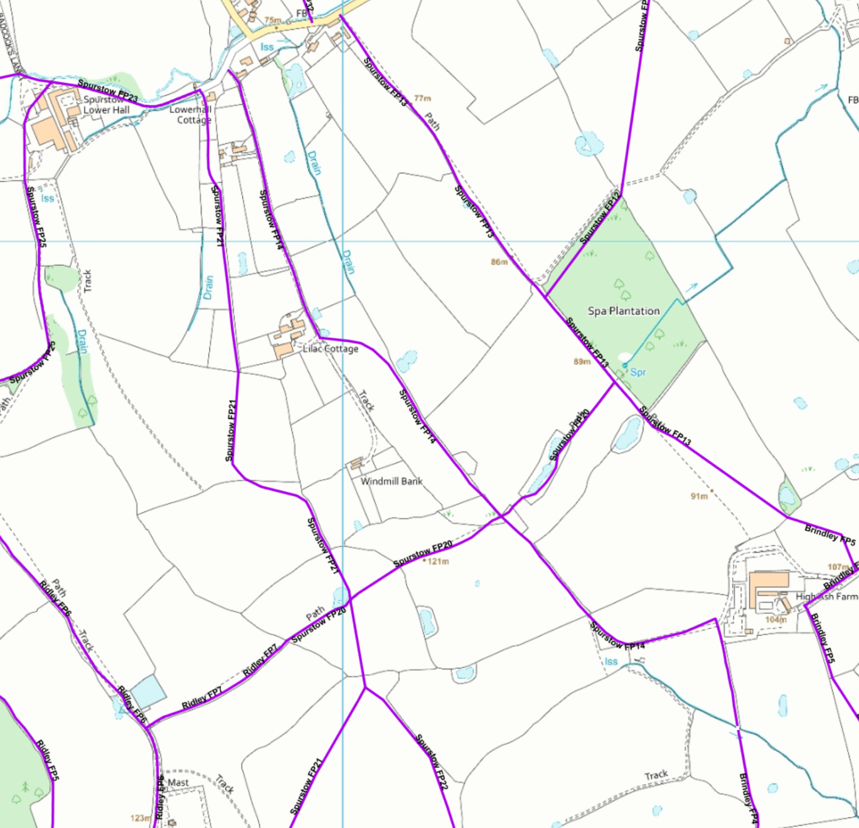
COMMENTS

