FOOTPATH INSPECTION REPORT
PARISH |  | Spurstow | FOOTPATH |  |  | FP15
FROM |  | Nursery Lane (Back Lane) south of Panama Hatty’s | TO |  |  | A49 (Back Lane) south of Panama Hatty’s
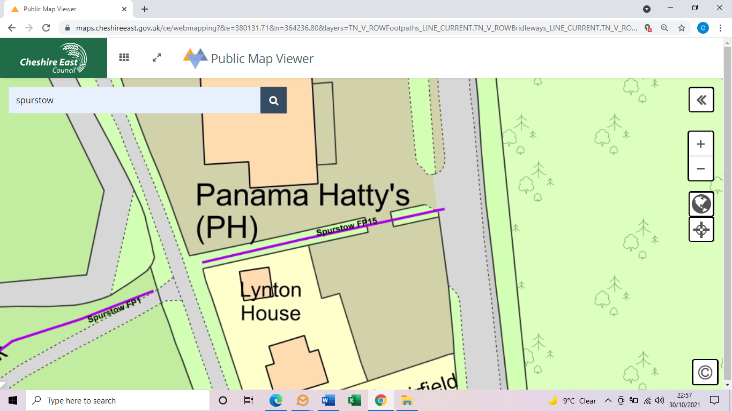
COMMENTS

INSPECTOR |  |  |  | DATE

