FOOTPATH INSPECTION REPORT
PARISH |  | Spurstow | FOOTPATH |  |  | FP16
FROM |  | Cappers Lane corner West of Cappers Lane Farm | TO |  |  | East towards The Dairy Farm on Long Lane
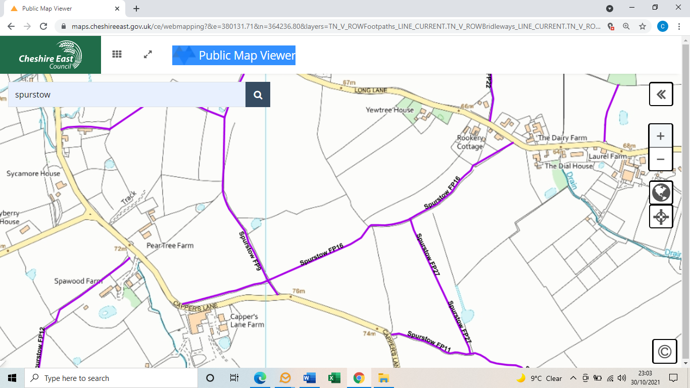
COMMENTS

INSPECTOR |  |  |  | DATE

