FOOTPATH INSPECTION REPORT
PARISH |  | Spurstow | FOOTPATH |  |  | FP17
FROM |  | From Spurstow Chapel | TO |  |  | North to meet Footpath 16
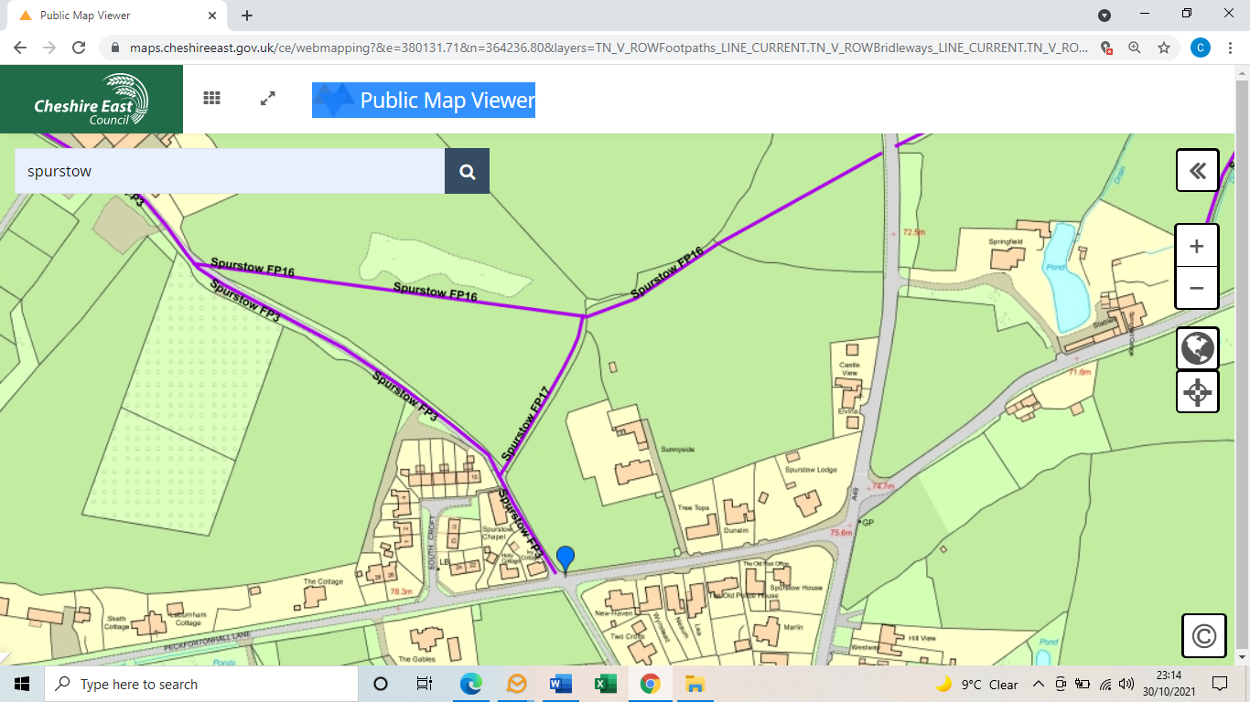
COMMENTS

INSPECTOR |  |  |  | DATE

