FOOTPATH INSPECTION REPORT
PARISH |  | Spurstow | FOOTPATH |  |  | FP18
FROM |  | From A49 North of Springfield | TO |  |  | East towards Bunbury Lane to meet Bunbury Footpath 15
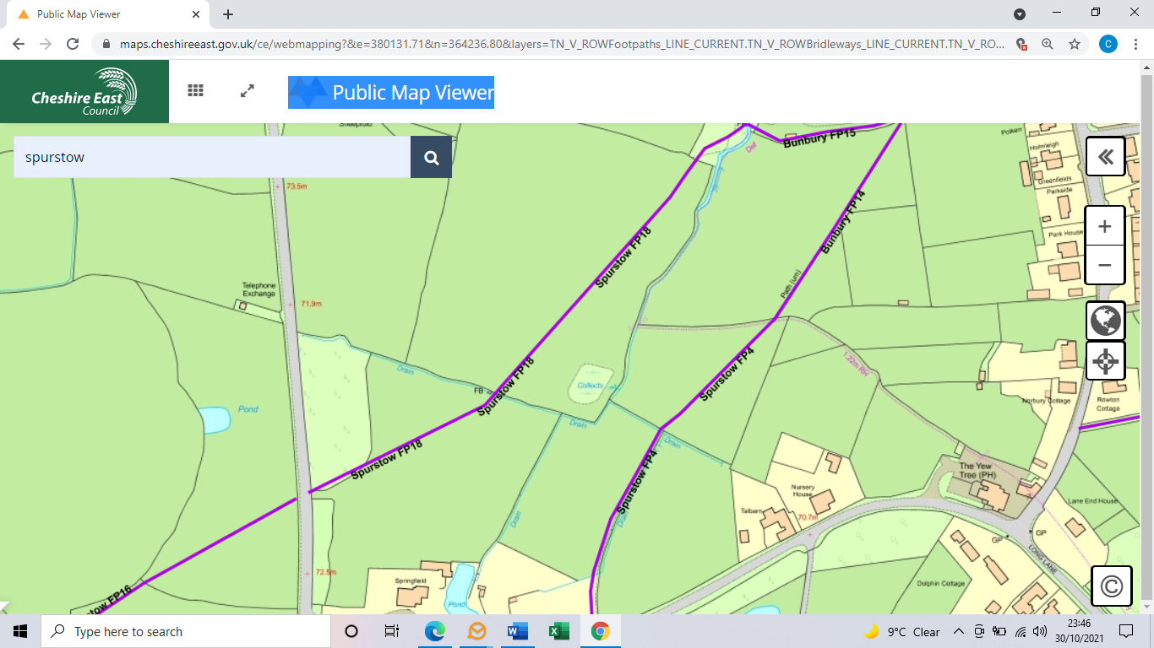
COMMENTS

INSPECTOR |  |  |  | DATE

