FOOTPATH INSPECTION REPORT
PARISH |  | Spurstow | FOOTPATH |  |  | FP19
FROM |  | East of White Cottage on Long Lane | TO |  |  | South West to meet Spurstow Footpath 16 near the corner of the field
COMMENTS 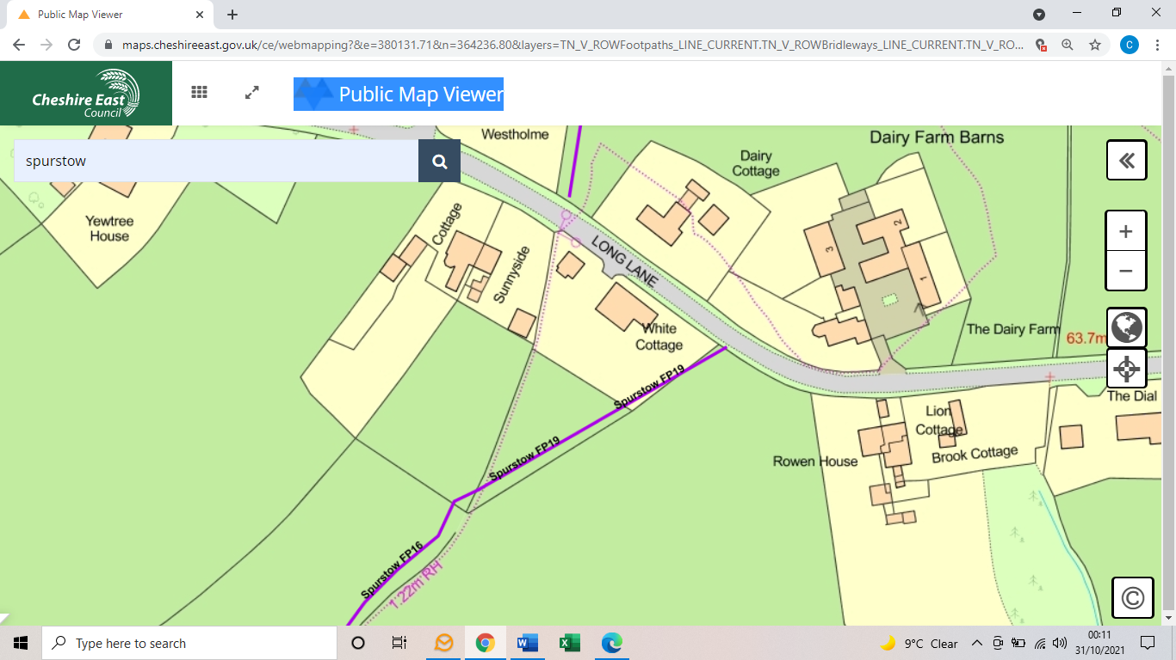

INSPECTOR |  |  |  | DATE

