FOOTPATH INSPECTION REPORT
PARISH | Spurstow | FOOTPATH | FP2
FROM | A49 | TO | Long Lane near Spurstow Hall
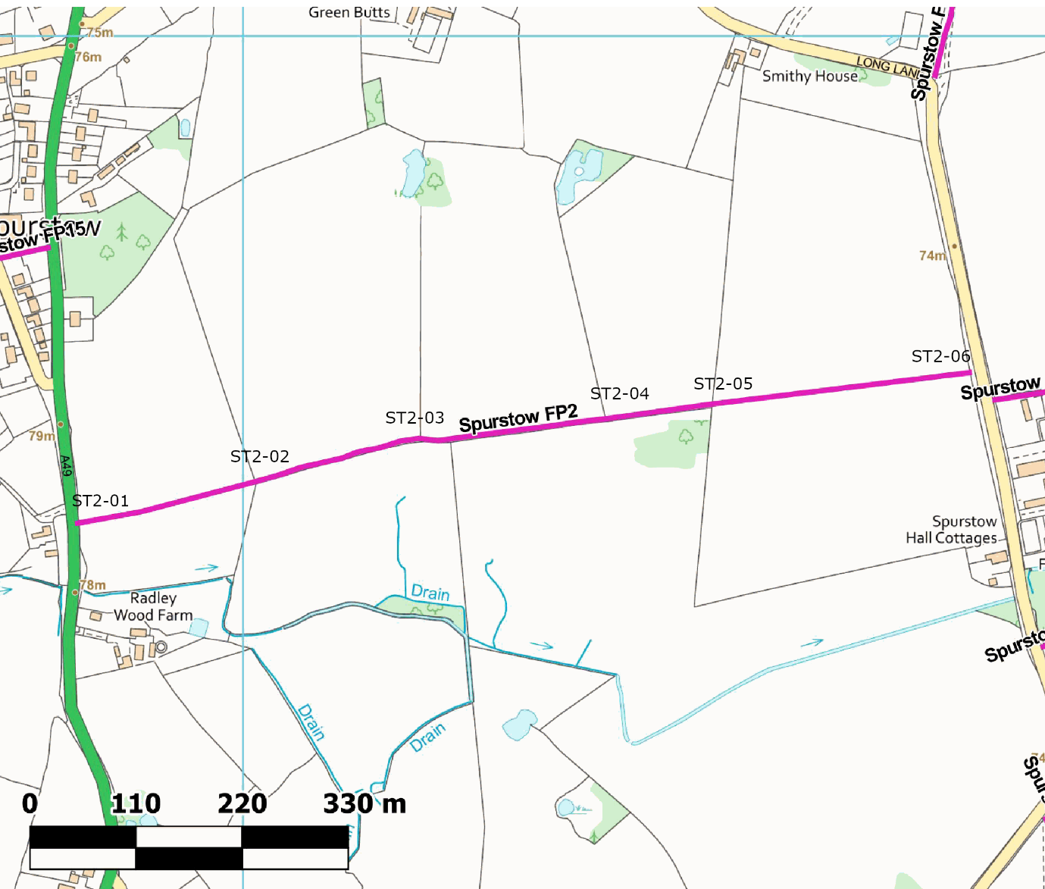
COMMENTS
The footpath starts at a fingerpost and stile on the A49, which was very overgrown and difficult to find, but in good condition.
It continues across the middle of the first field, then along the edge of three more fields, then across the middle of a further field to Long Lane near Spurstow Hall.
There are stiles between each of the fields- each rather overgrown and in good repair with small yellow way marks on each The next stile could be seen from the previous stile in each case, once you knew where to look.
We will cut back the hedges a little to make the stiles easier to use.
The footpath ends with a fingerpost and stile, also overgrown and in fair repair though it needs a big step up from the lower road level.
The footpath has signs of occasional use with footsteps in the only ploughed field.
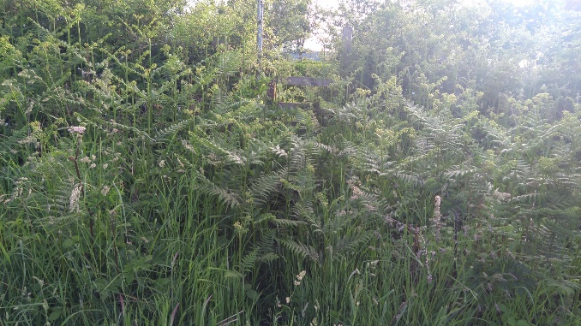Stile 01 from road before clearing |  | 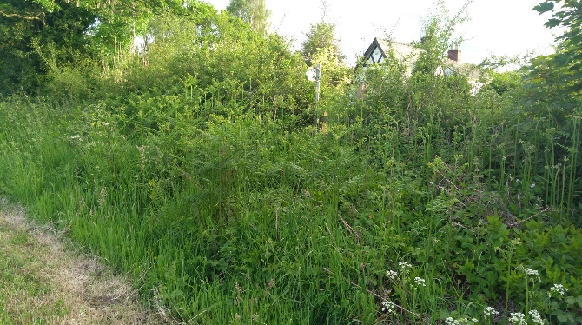Stile 01 from field with finger post
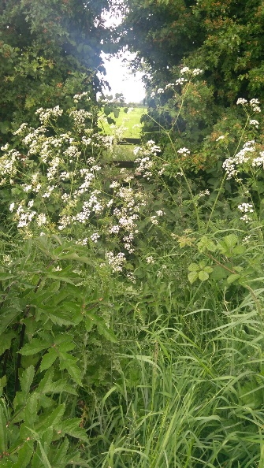 Stile 02 |  | 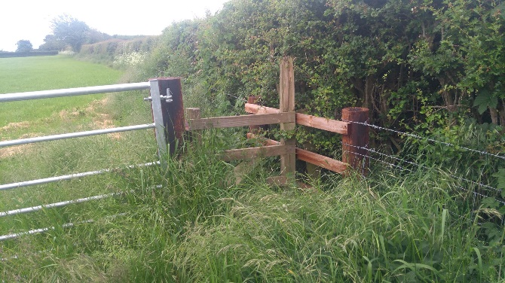Stile 03
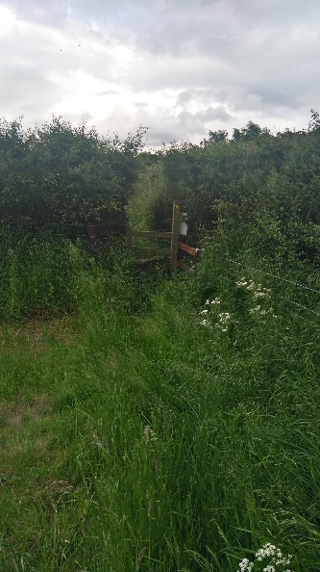 Stile 04 looking east |  | 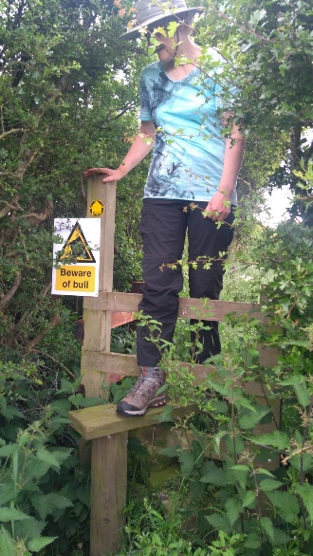 Stile 04 looking west

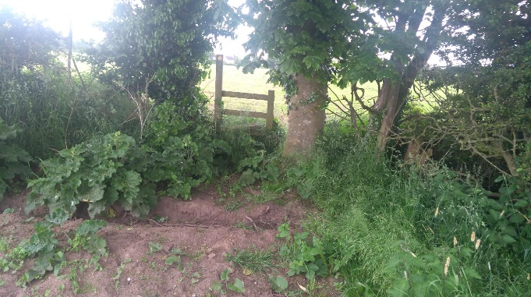Stile 05 |  | 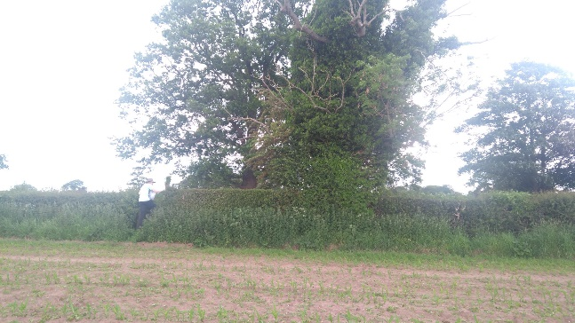Stile 06 from field
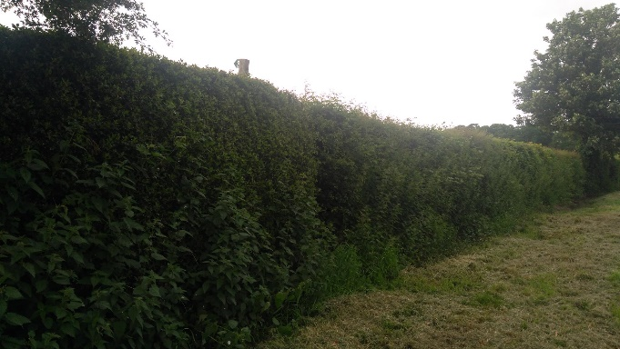Stile 06 from road with finger post
INSPECTOR | Katherine Hutchinson | DATE | 9 June 2021

