FOOTPATH INSPECTION REPORT
PARISH |  | Spurstow | FOOTPATH |  |  | FP20
FROM |  | Footpath 13 on the South West edge of Spa Plantation | TO |  |  | South west towards Ridley Green crossing footpaths 14 and 21
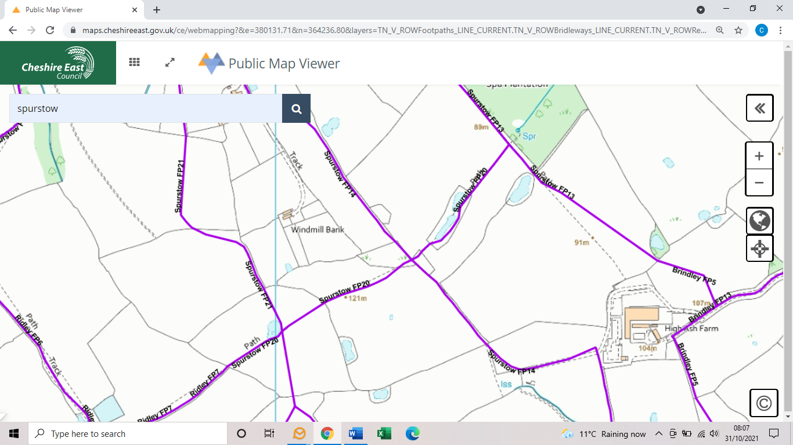
COMMENTS

INSPECTOR |  |  |  | DATE

