FOOTPATH INSPECTION REPORT
PARISH |  | Spurstow | FOOTPATH |  |  | FP21
FROM |  | Just West of Lowerhall Cottage on Bathwood Lane | TO |  |  | South, then South West towards Ridley Bank Cottage on the A534
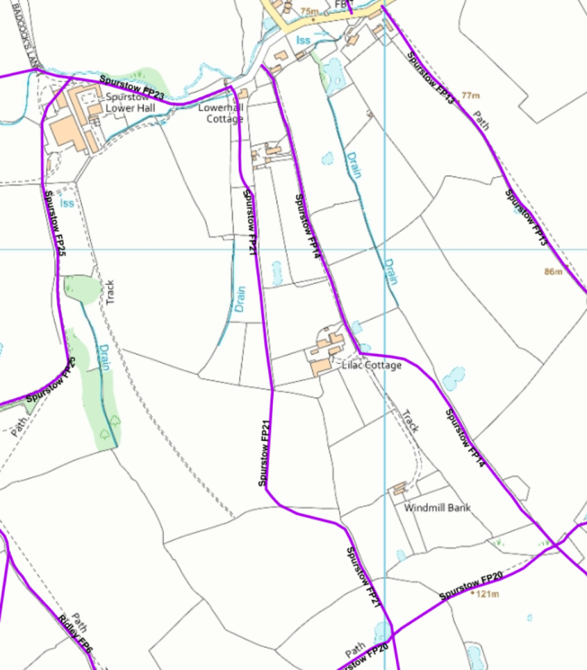
COMMENTS

INSPECTOR |  |  |  | DATE

