FOOTPATH INSPECTION REPORT
PARISH |  | Spurstow | FOOTPATH |  |  | FP22
FROM |  | Footpath 21 | TO |  |  | South South West towards Brindley
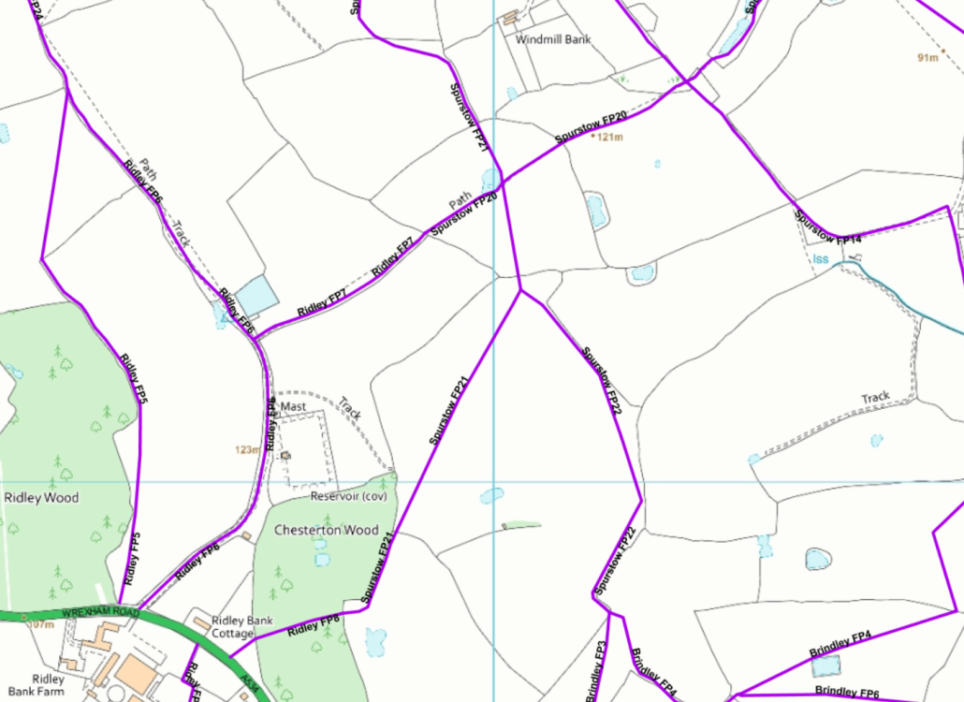
COMMENTS

INSPECTOR |  |  |  | DATE

