FOOTPATH INSPECTION REPORT
PARISH |  | Spurstow | FOOTPATH |  |  | FP23
FROM |  | Bathwood Lane west of Lowerhall Cottage | TO |  |  | West towards Footpath 24
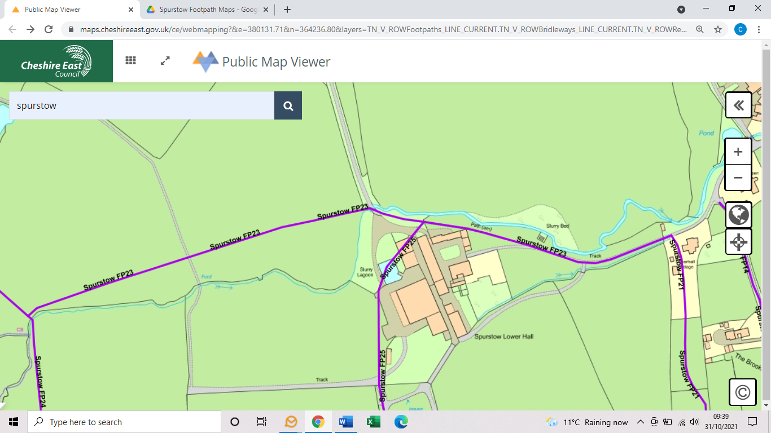
COMMENTS

INSPECTOR |  |  |  | DATE

