FOOTPATH INSPECTION REPORT
PARISH |  | Spurstow | FOOTPATH |  |  | FP24
FROM |  | Badcock’s Lane opposite two cottages | TO |  |  | South towards footpath 25
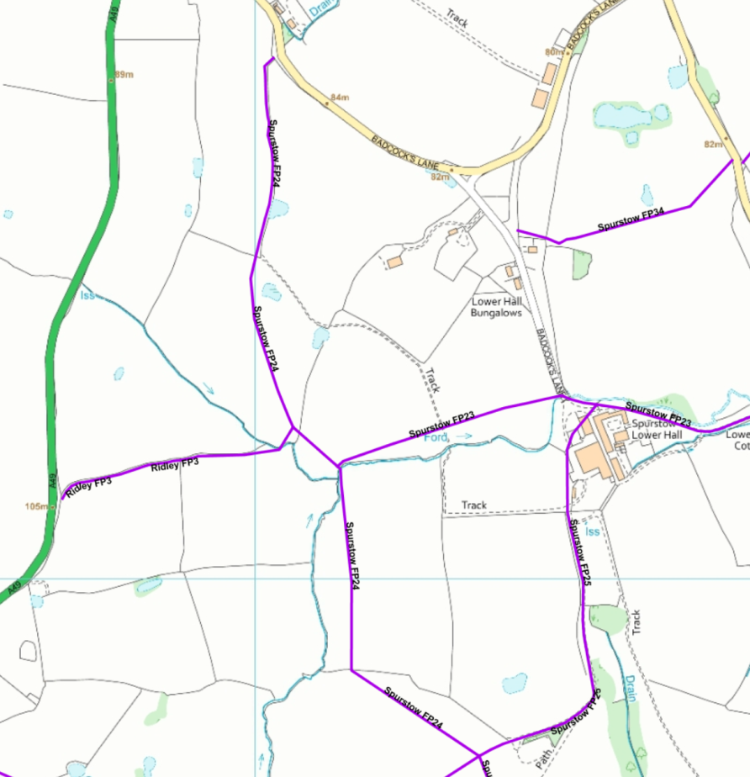
COMMENTS
Spurstow footpath 24 (FP24) starts on Badcocks lane just East of the A 49 near the Caravan Park with a fingerpost and stile which were in poor condition as the fingerpost had fallen over and the top step of the stile was very mobile and dangerous. There were also several black bin bags of rubbish in the field next to the stile (photo 1).
It continues south across the first field along the fence line, passing a pond on the left, to a slightly overgrown, but easily cleared, well-marked stile which was in good repair. (Photo 2)
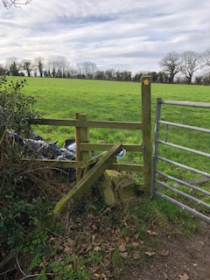
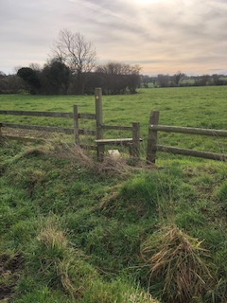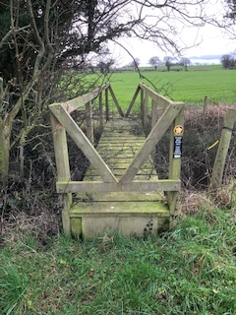
Photo 1 Photo 2 Photo 3

The footpath continues across the field, passing a copse on the left, down towards a boggy area and a bridge which is in good repair but needs the overgrowth cutting back. (photo 3) This bridge crosses to Ridley FP3 which eventually rejoins the A49. The main FP24 bears off left before this bridge into another field with yellow marker signs on the left gatepost. (photo 4)

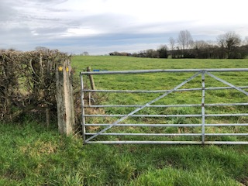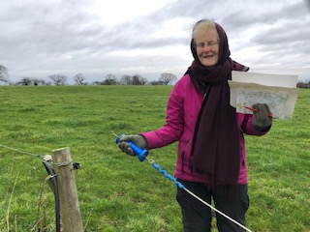
Photo 4 Photo 5
Immediately after the gate is an electric fence which has handles on the section across the gateway entrance that can be unhooked to allow safe passage. (Photo 5)
Bear right through the gate and there is another well maintained footbridge in the treeline over a stream continuing south on FP24 or you can go left after the bridge to follow Spurstow FP 23. (Photo 6 looking south & Photo 7 looking back towards the gate you have just come through)

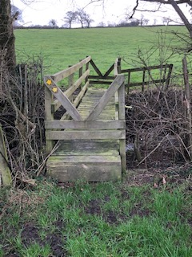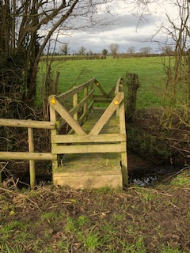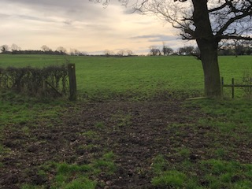
Photo 6 Photo 7 Photo 8
Continue south across the field on Spurstow FP 24 to an old gate opening where there is a small yellow way marker on the left-hand post. A tree marks the other side of the opening. (Photo 8)
Bear slightly left up over undulating fields to a well-maintained stile with a yellow way marker next to the gate in a boggy area. (Photo 9) Although there is no marker in the field you have walked across, another footpath (Spurstow FP25) crosses FP24 and runs from Spurstow Lower Hall to Ridley FP4. Cross over the stile (Photo 9) and follow the field boundary on the right for the last short stretch of Spurstow FP24. The views are lovely looking back towards the Peckforton Hills and Castle. (Photo 10).

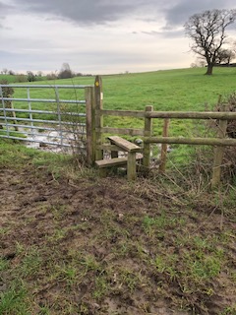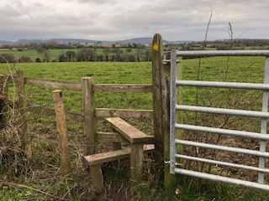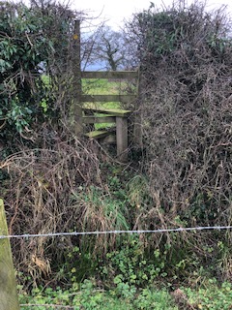
Photo 9 Photo 10 Photo 11
The end of the footpath is marked by a stile on the right (Photo 11) which leads on to Spurstow FP39. The stile appears to be in good repair but is overgrown and has a barbed wire fence with a small ditch in front of it and a steep bank up to it making it difficult to cross towards Ridley.

INSPECTOR | Barbara Jones & Katherine Hutchinson |  |  | DATE | 28.01.22

