FOOTPATH INSPECTION REPORT
PARISH |  | Spurstow | FOOTPATH |  |  | FP24
FROM |  | Badcock’s Lane opposite two cottages | TO |  |  | South towards footpath 25
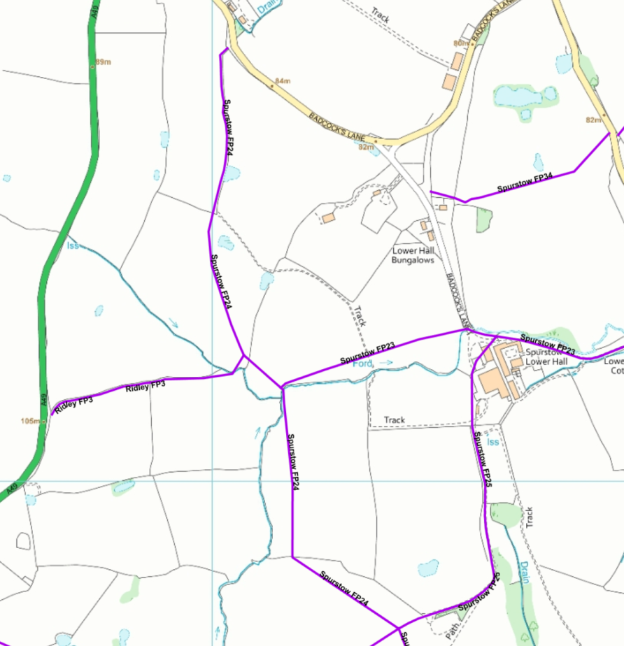
COMMENTS

INSPECTOR |  |  |  | DATE

