FOOTPATH INSPECTION REPORT
PARISH |  | Spurstow | FOOTPATH |  |  | FP25
FROM |  | Spurstow Lower Hall, south through farmyard | TO |  |  | Bear right towards Ridley
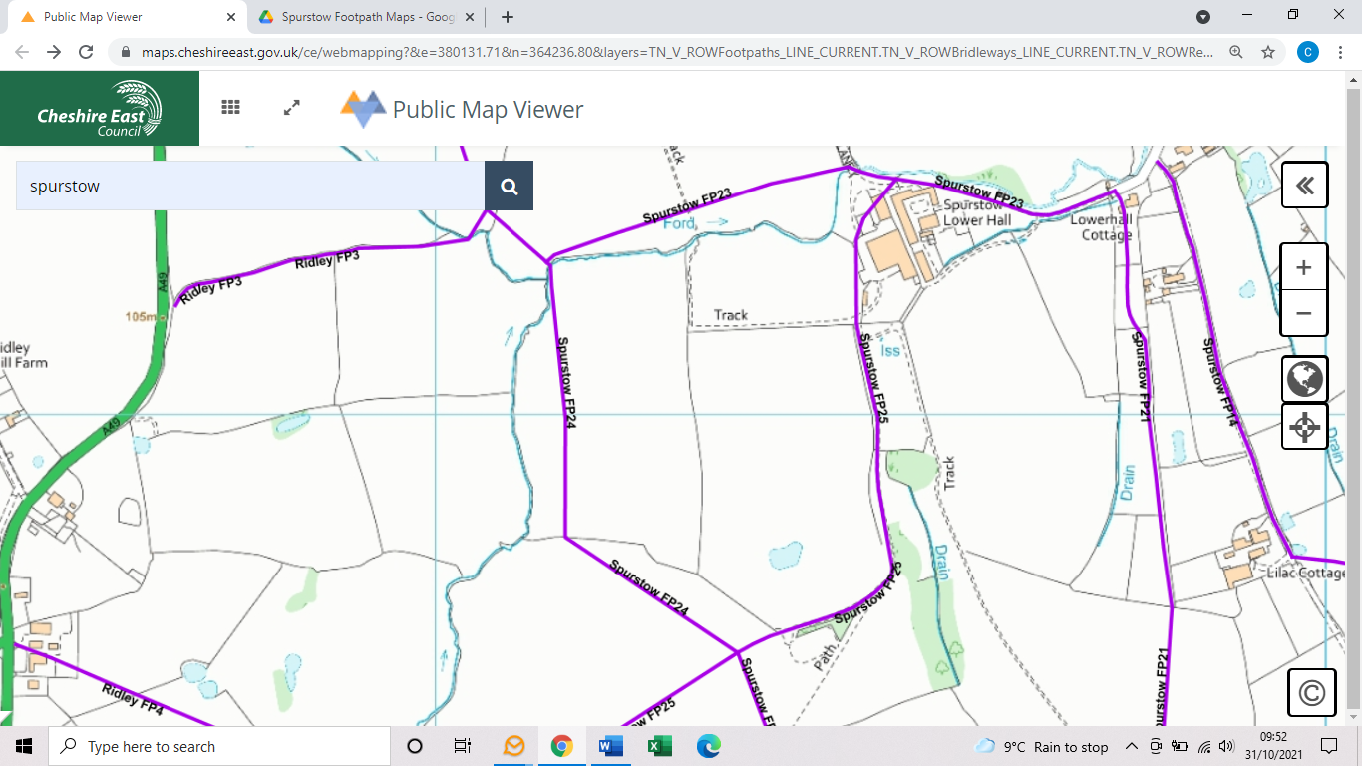
COMMENTS

INSPECTOR |  |  |  | DATE

