FOOTPATH INSPECTION REPORT
PARISH |  | Spurstow |  | FOOTPATH |  | FP26
FROM |  | This is only about 36m long, and runs South South West from a bend in Footpath 24. |  | TO |  | Meets the end of Ridley Footpath 3 after crossing a small stream.
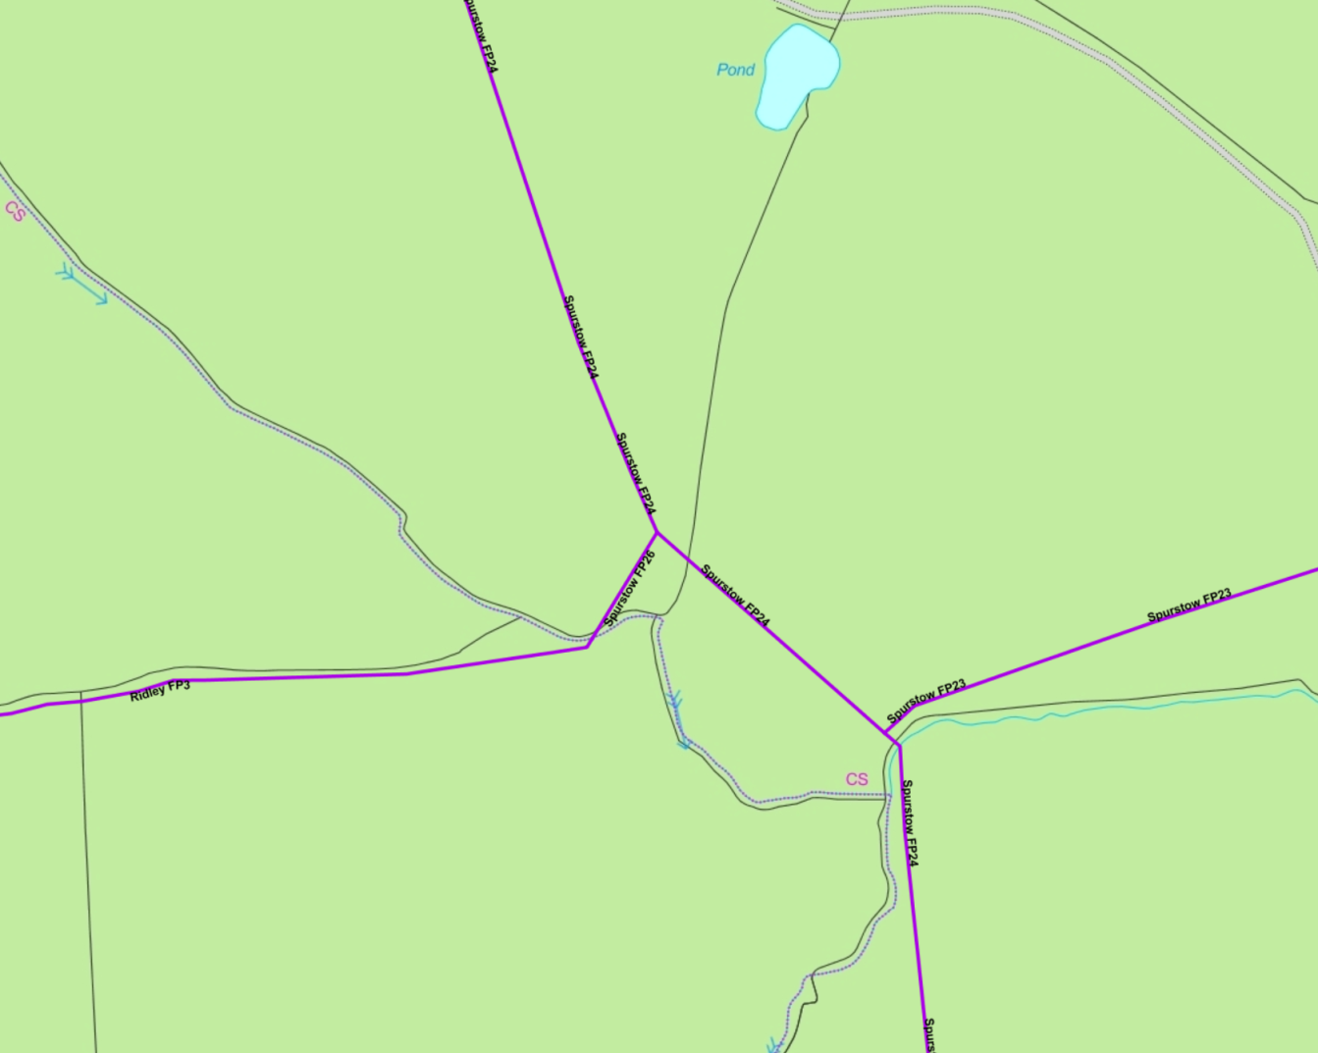
COMMENTS

INSPECTOR |  |  | DATE

