FOOTPATH INSPECTION REPORT
PARISH |  | Spurstow |  | FOOTPATH |  | FP27
FROM |  | Spurstow Footpath 11, accessed from the corner of Cappers Lane |  | TO |  | North towards Spurstow Footpath 16
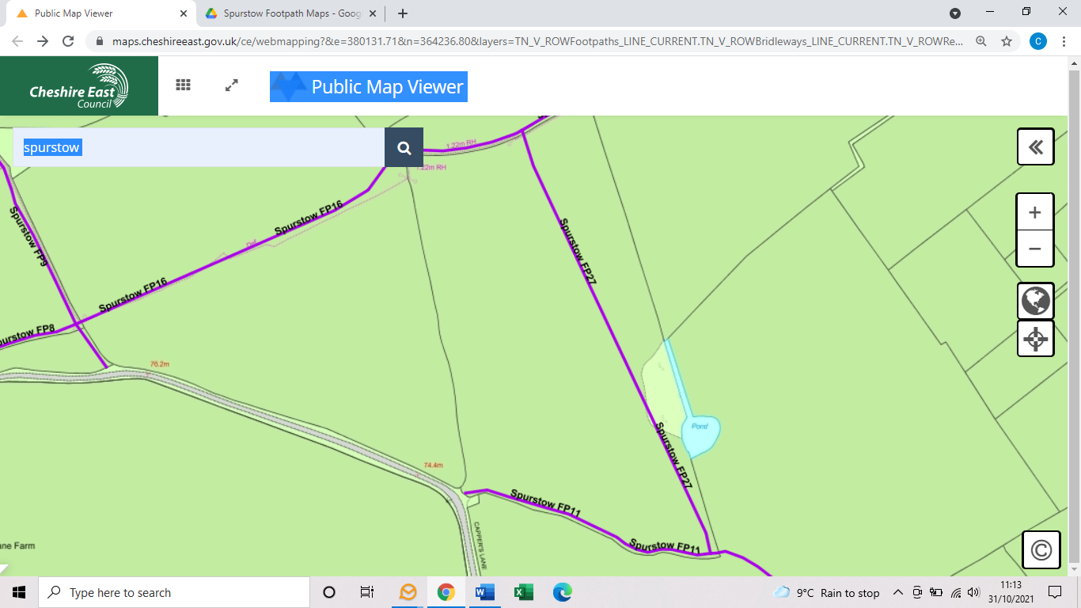
COMMENTS

INSPECTOR |  |  | DATE

