FOOTPATH INSPECTION REPORT
PARISH |  | Spurstow |  | FOOTPATH |  | FP28
FROM |  | This footpath is only 35m long. It runs North from opposite Bank Cottage on Cappers Lane |  | TO |  | To meet Haughton Footpath 6
On Cappers 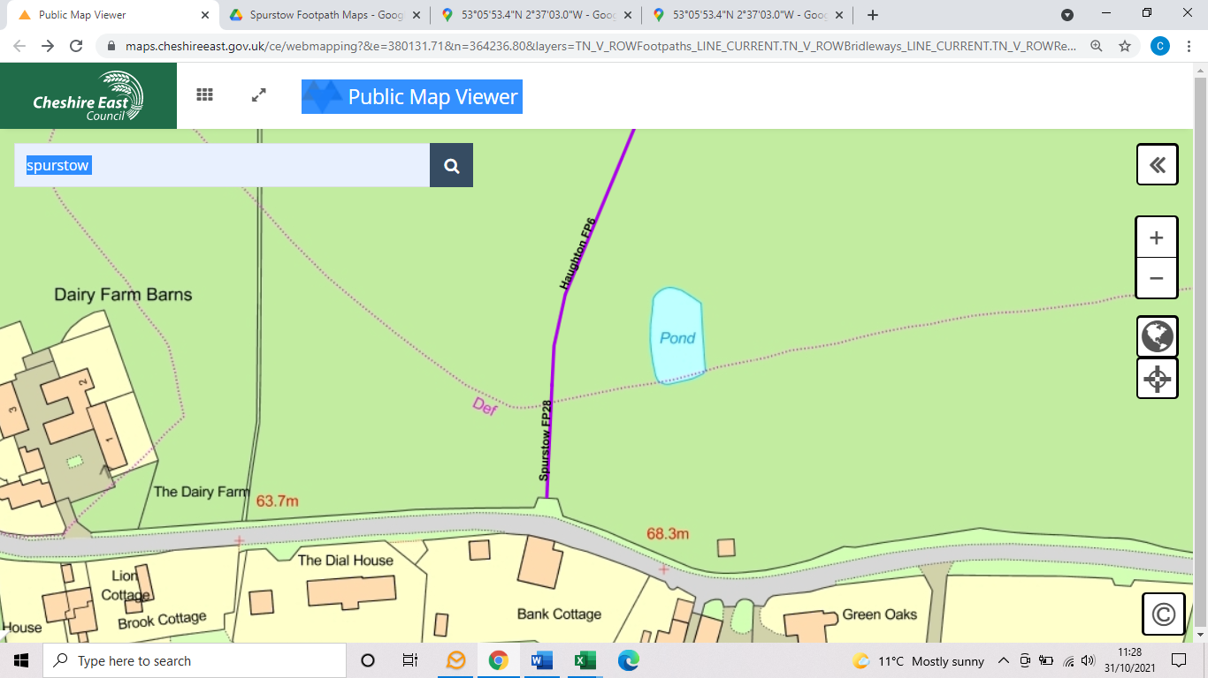
COMMENTS

INSPECTOR |  |  | DATE

