FOOTPATH INSPECTION REPORT
PARISH |  | Spurstow |  | FOOTPATH |  | FP29
FROM |  | East of Oak Cottage on Long Lane |  | TO |  | Runs North West towards Claymore on Hall Lane
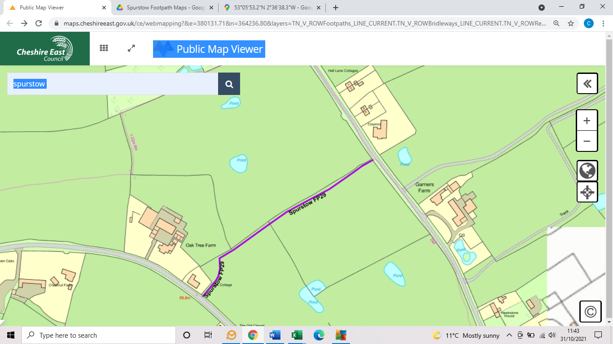
COMMENTS

INSPECTOR |  |  | DATE

