FOOTPATH INSPECTION REPORT
PARISH |  | Spurstow | FOOTPATH |  | FP3
FROM |  | Peckforton Hall Lane near Southcroft | TO |  | Yew Tree Farm via Haycroft
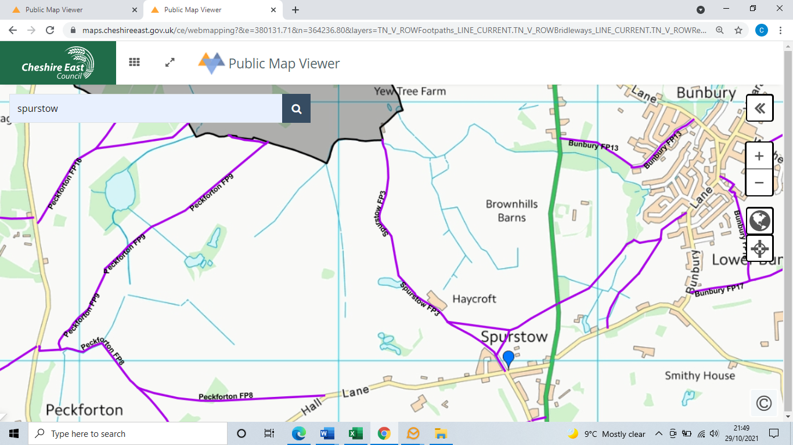
COMMENTS
On a cold December day this was not too muddy to be a nice walk, all the stiles and the bridge were in good order. The hedges were all well cut back and it was clearly signposted.
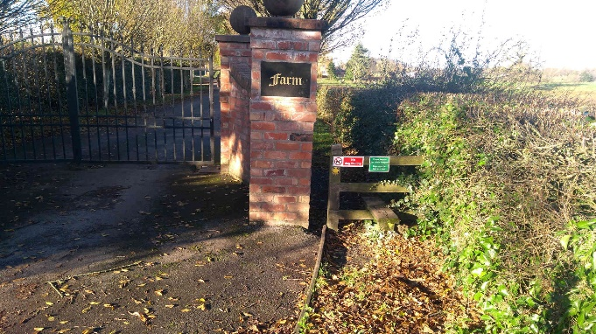  The entrance to Haycroft farm from the tarmac access road, with the stile next to the gate. |  |  | 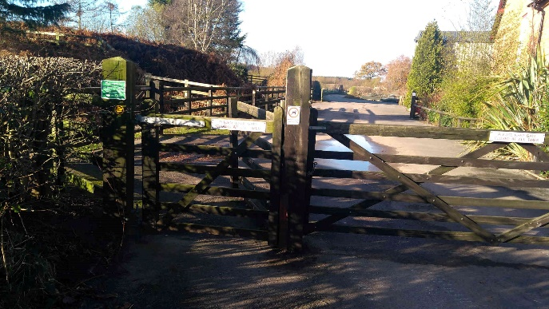  The gate to the farm yard with the footpath gate next to the farm yard gate.
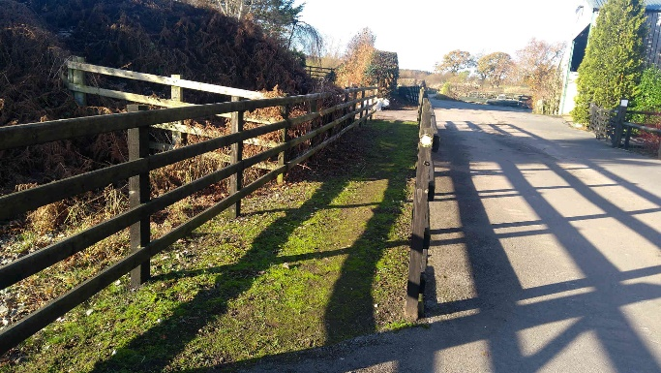  The fence separating the footpath from the farmyard |  |  | 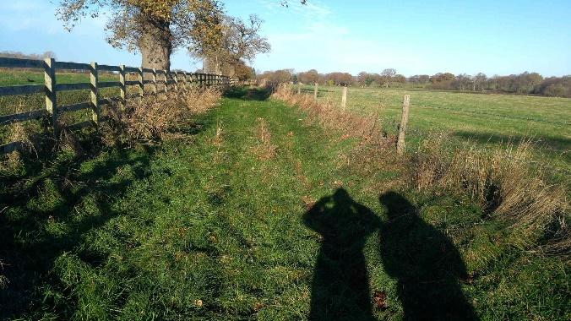  The footpath running along the first field boundary after Haycroft Farm
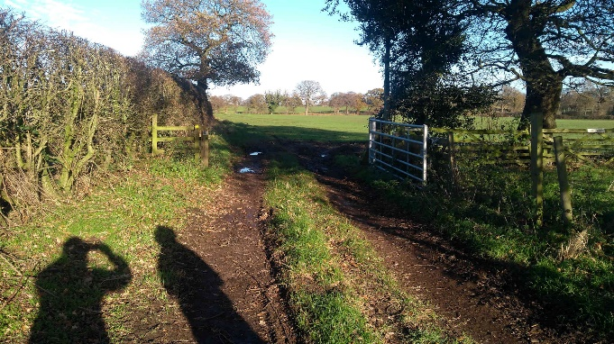  The stile into the second field |  |  | 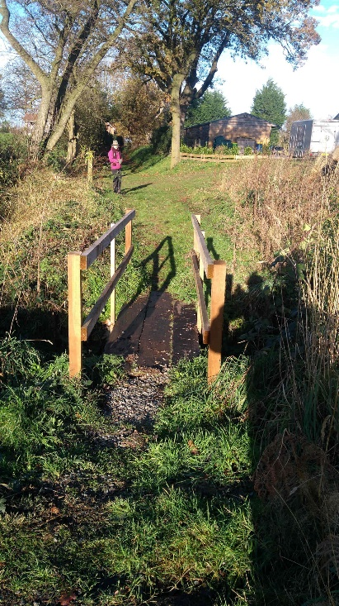  Bridge over the drainage ditch (small stream) just before Moss Cottage- where the footpath goes into Beeston in Cheshire East
INSPECTOR | Katherine and Stephen Hutchinson |  | DATE | 2 December 2021

