FOOTPATH INSPECTION REPORT
PARISH |  | Spurstow | FOOTPATH |  | FP3
FROM |  | Peckforton Hall Lane near Southcroft | TO |  | Yew Tree Farm via Haycroft
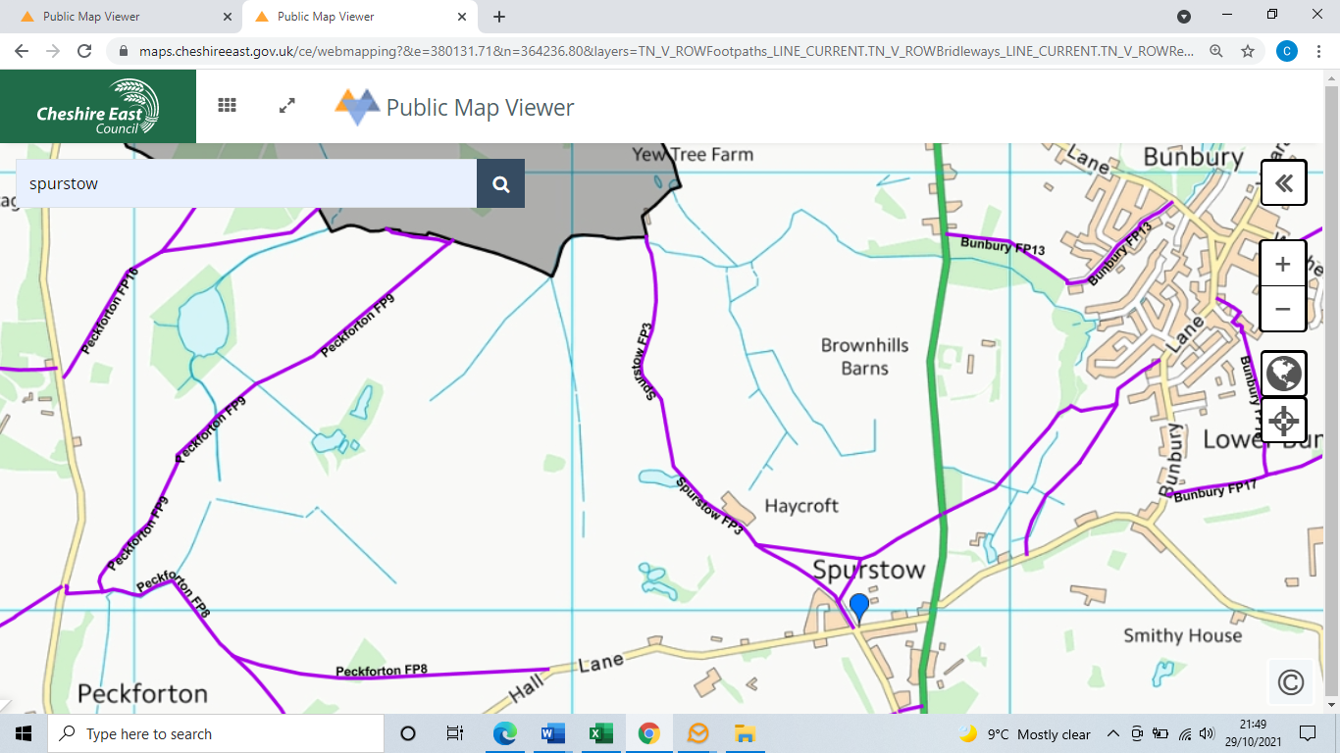
COMMENTS

INSPECTOR |  |  | DATE

