FOOTPATH INSPECTION REPORT
PARISH |  | Spurstow |  | FOOTPATH |  | FP30
FROM |  | Runs West South West from opposite The Courtyard on Hall Lane |  | TO |  | Towards Meadowside on Long Lane
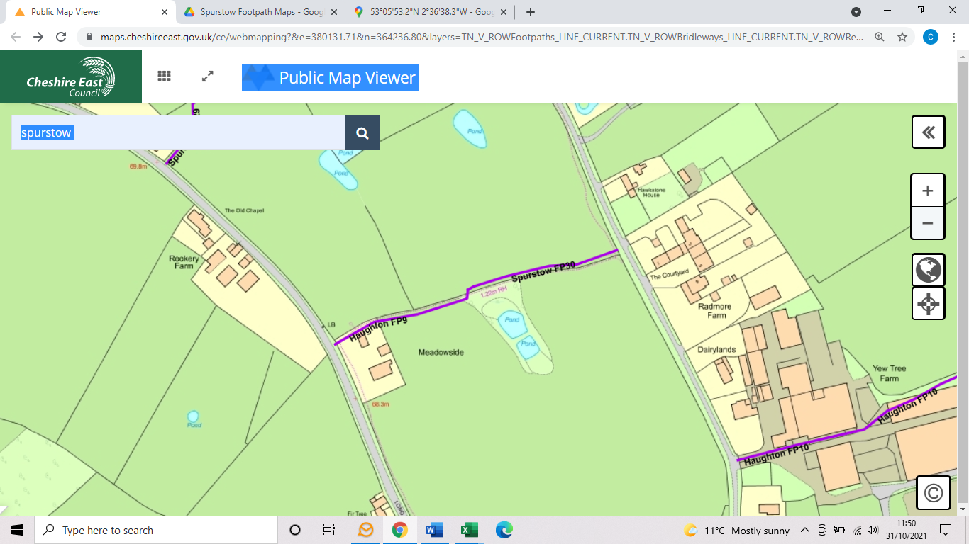
COMMENTS

INSPECTOR |  |  | DATE

