FOOTPATH INSPECTION REPORT
PARISH |  | Spurstow |  | FOOTPATH |  | FP31
FROM |  | From Ivy Cottage on Long Lane |  | TO |  | East towards the drive of Brook Cottages on Hall Lane
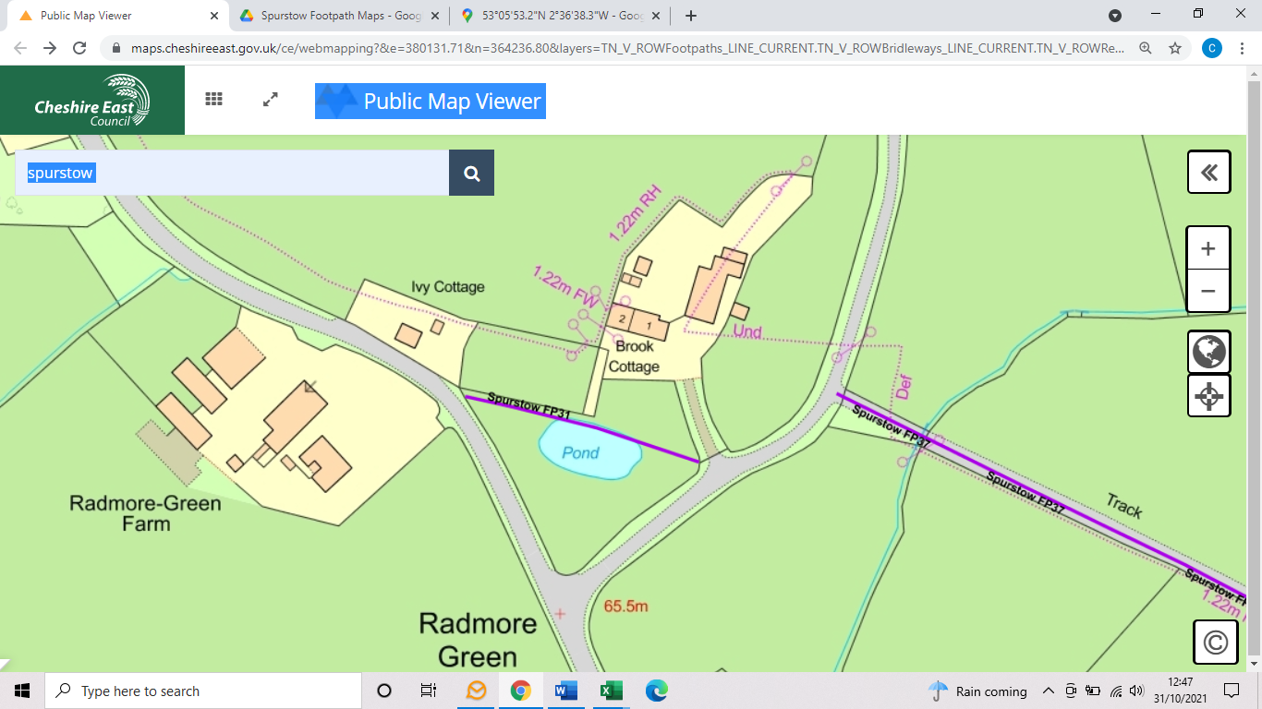
COMMENTS

INSPECTOR |  |  | DATE

