FOOTPATH INSPECTION REPORT
PARISH |  | Spurstow |  | FOOTPATH |  | FP32
FROM |  | Leads South from a point on Badcocks Lane just south of the junction with Long Lane |  | TO |  | Bathwood lane opposite Bath House
COMMENTS 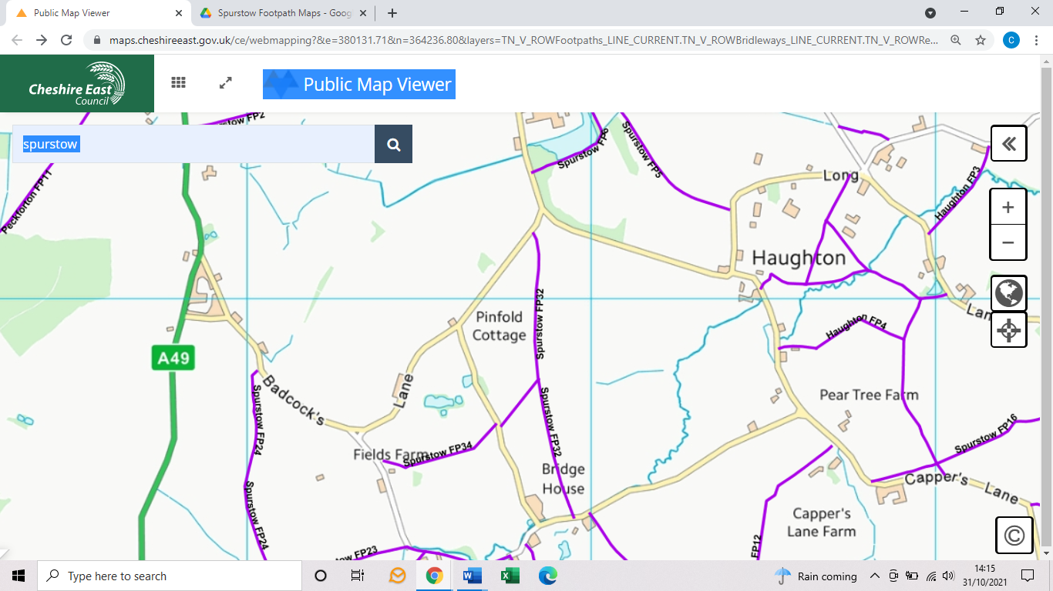

INSPECTOR |  |  | DATE

