FOOTPATH INSPECTION REPORT
PARISH |  | Spurstow |  | FOOTPATH |  | FP33
FROM |  | A very short path that leads from Footpath 32 South West |  | TO |  | c
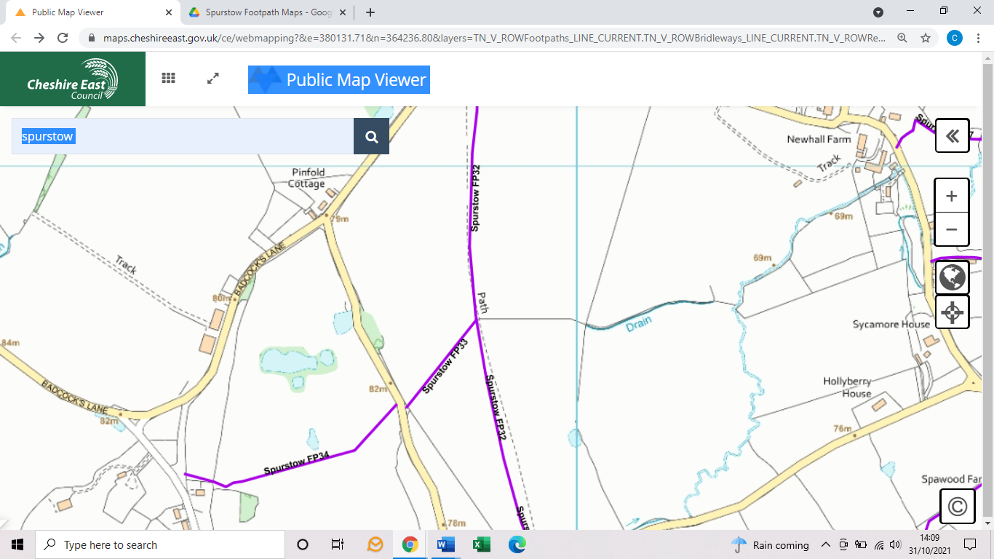
COMMENTS

INSPECTOR |  |  | DATE

