FOOTPATH INSPECTION REPORT
PARISH |  | Spurstow |  | FOOTPATH |  | FP34
FROM |  | Leads East as a continuation of Footpath 33 from the lane that runs between Pinfold Cottage towards Coxey Green |  | TO |  | Meets Badcocks Lane near to Fields Farm
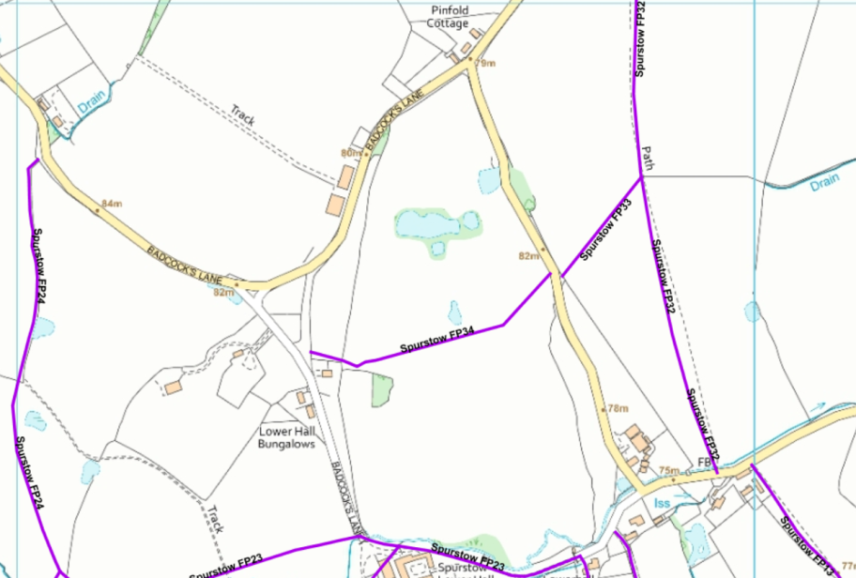
COMMENTS

INSPECTOR |  |  | DATE

