FOOTPATH INSPECTION REPORT
PARISH |  | Spurstow |  | FOOTPATH |  | FP35
FROM |  | North of Broom Butts |  | TO |  | Heads East to meet Haughton Footpath 4
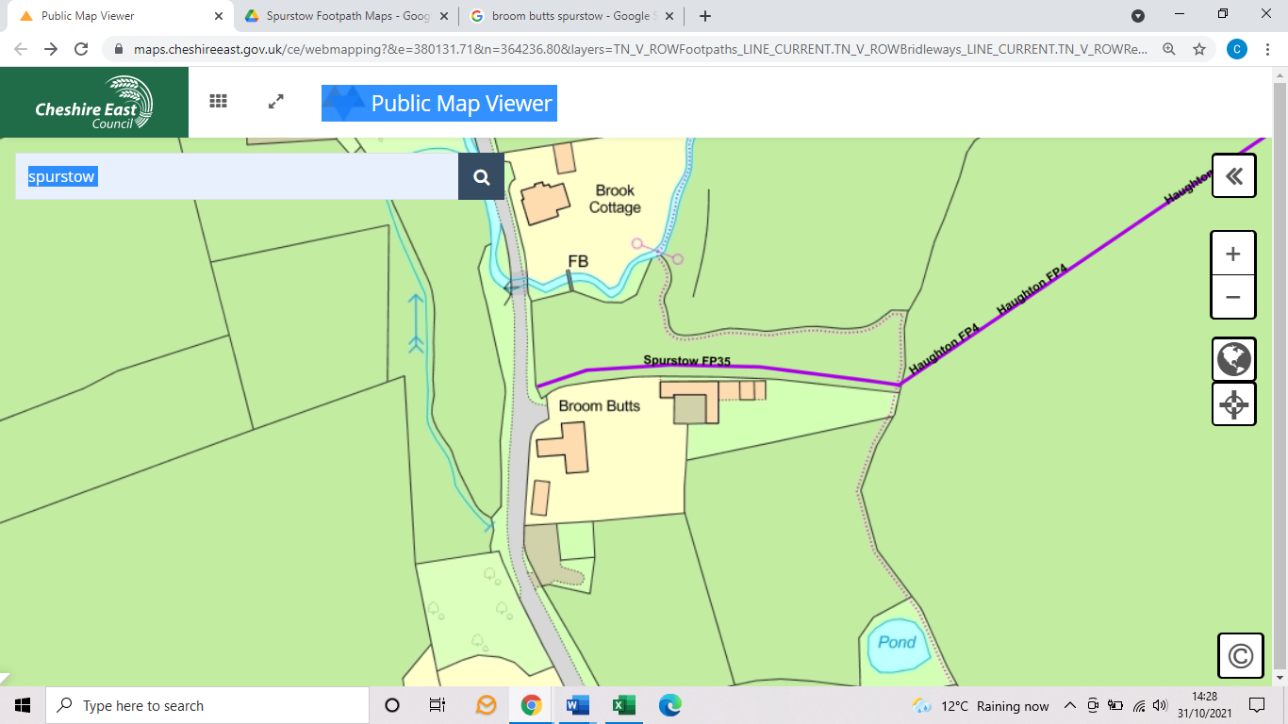
COMMENTS

INSPECTOR |  |  | DATE

