FOOTPATH INSPECTION REPORT
PARISH |  | Spurstow |  | FOOTPATH |  | FP36
FROM |  | Heads North from the corner of Long Lane just East of Oaklands |  | TO |  | Meet Bunbury footpath 18 at the end of the track
COMMENTS 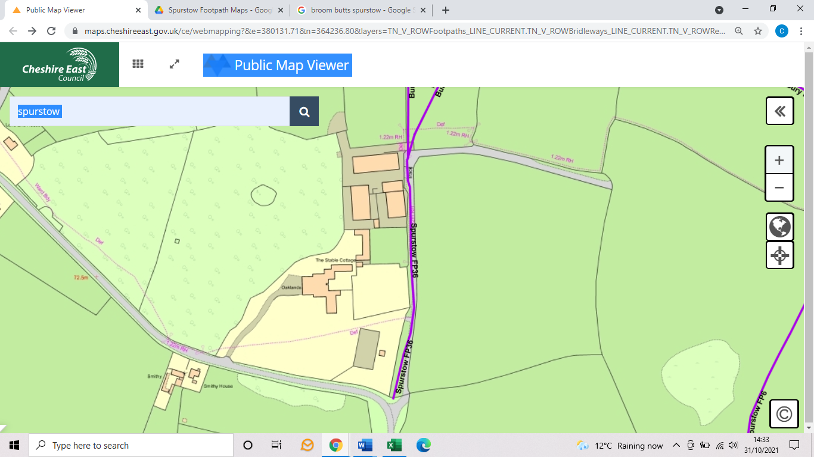

INSPECTOR |  |  | DATE

