FOOTPATH INSPECTION REPORT
PARISH |  | Spurstow |  | FOOTPATH |  | FP37
FROM |  | Hall Lane opposite Brook Cottage |  | TO |  | Runs South East to meet Brindley Footpath 24
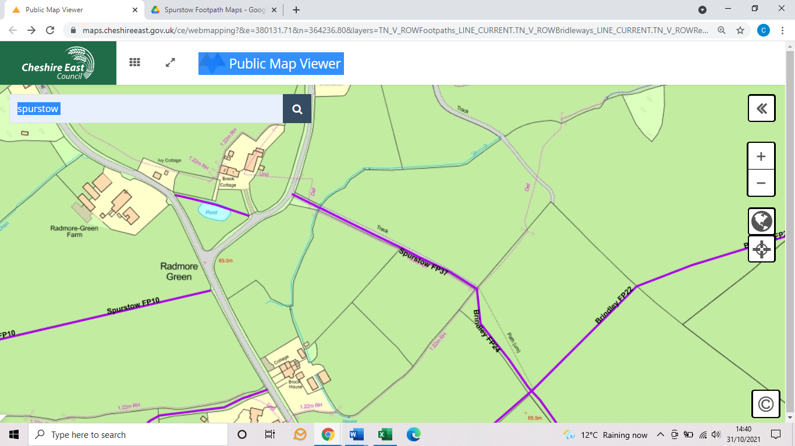
COMMENTS

INSPECTOR |  |  | DATE

