FOOTPATH INSPECTION REPORT
PARISH |  | Spurstow |  | FOOTPATH |  | FP38
FROM |  | A really short path that runs about 17m to the north of the garden of Keepers Cottage |  | TO |  | Part-way down the garden of Keepers Cottage to meet Brindley Footpath 1
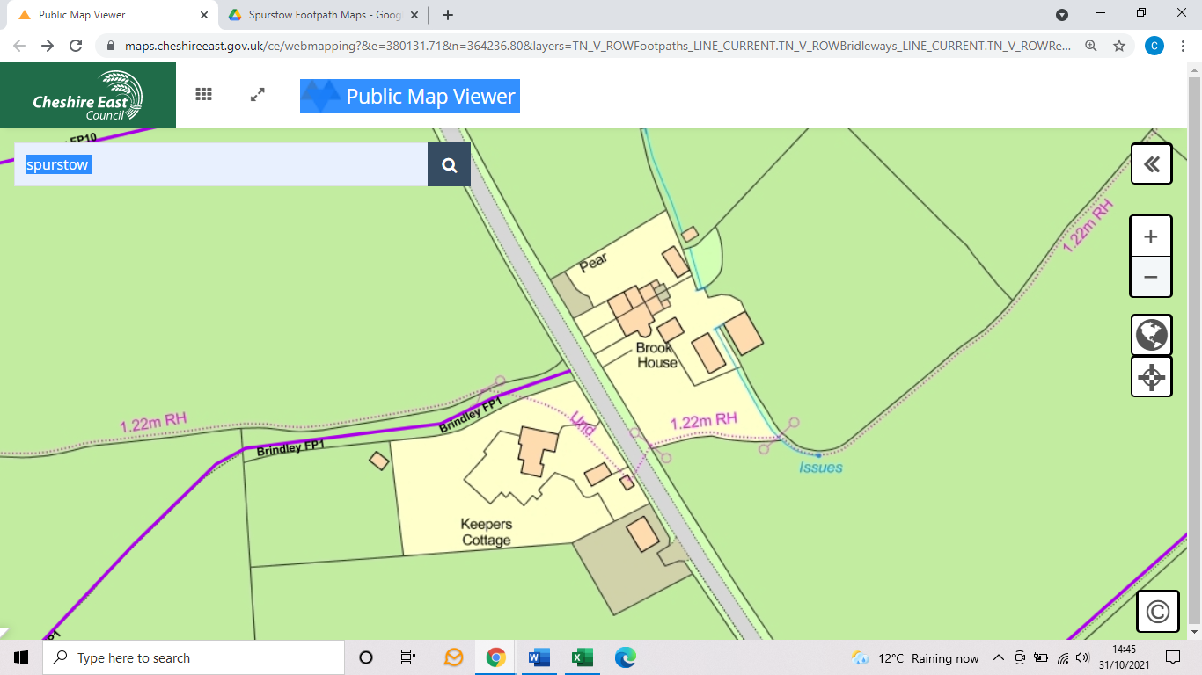
COMMENTS 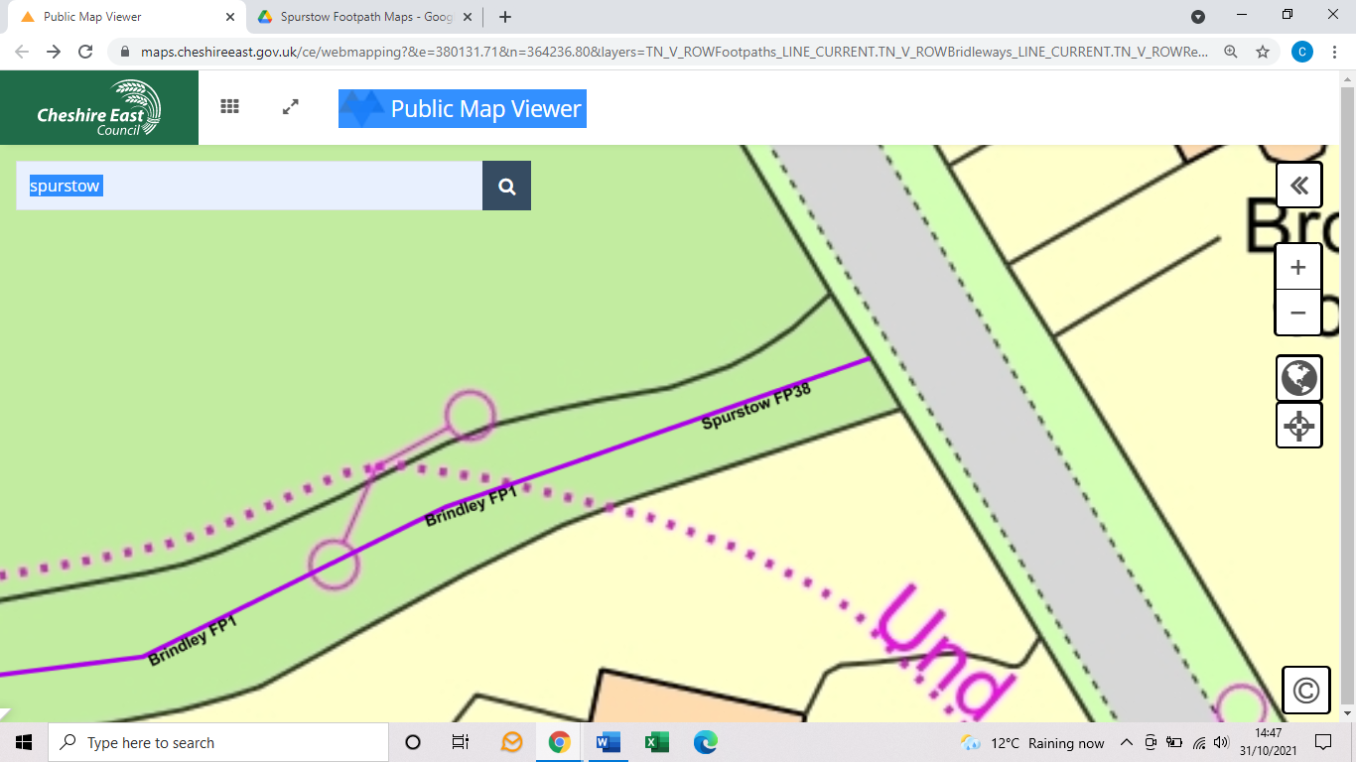

INSPECTOR |  |  | DATE

