FOOTPATH INSPECTION REPORT
PARISH |  | Spurstow |  | FOOTPATH |  | FP39
FROM |  | Ridley Footpath 5 – Ridley footpath 5 runs north from the A534 near Ridley Bank Farm |  | TO |  | Ridley Footpath 6
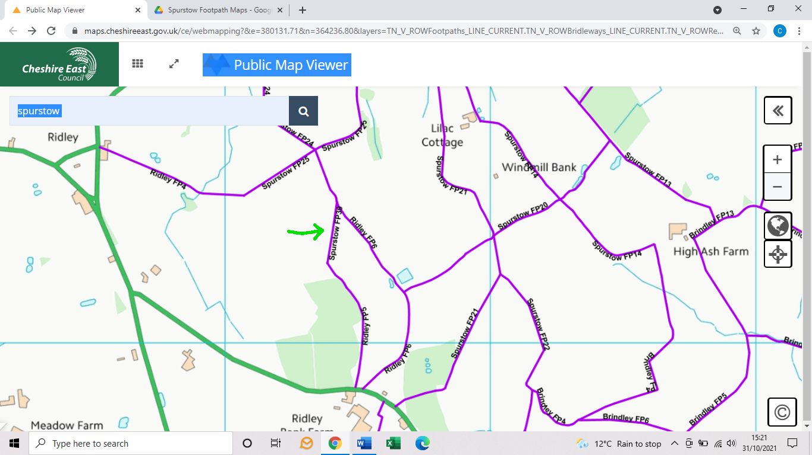
COMMENTS

INSPECTOR |  |  | DATE

