FOOTPATH INSPECTION REPORT
PARISH |  | Spurstow | FOOTPATH |  |  | FP4
FROM |  | Long Lane East of Springfield | TO |  |  | Towards Bunbury
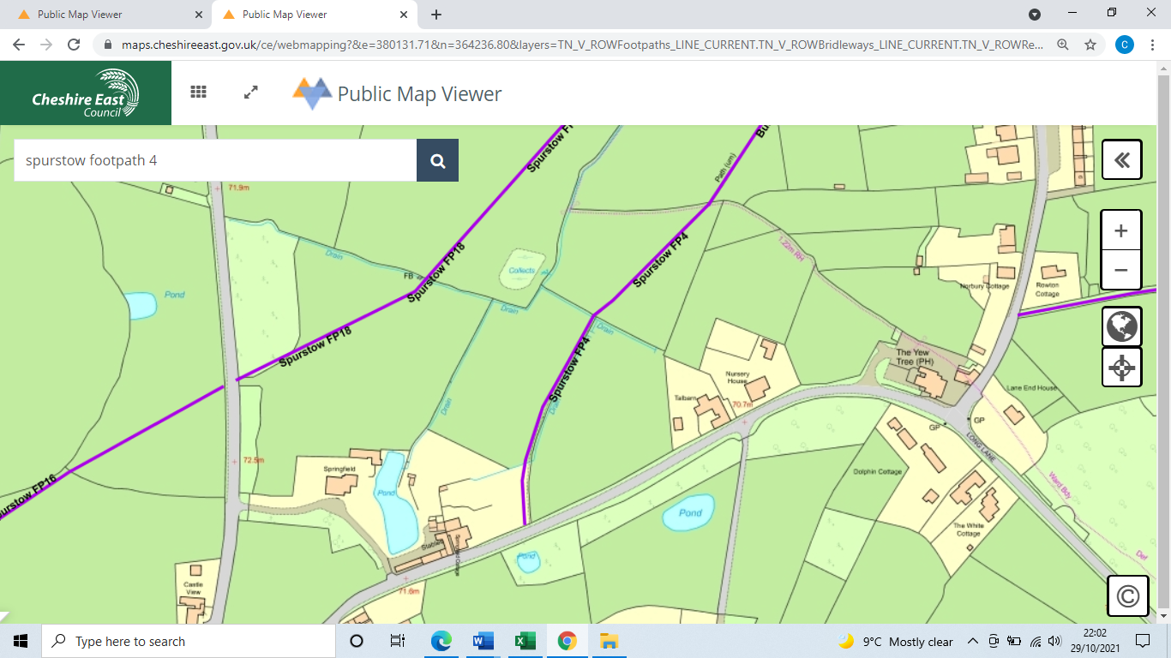
COMMENTS

INSPECTOR |  |  |  | DATE

