FOOTPATH INSPECTION REPORT
PARISH |  | Spurstow |  | FOOTPATH |  | FP41
FROM |  | This path is a very short extension (10-15metres or so) of Bunbury Footpath 18 South to meet Footpath 36 |  | TO |  | Meets Spurstow Footpath 36 at the corner of the track to the East of The Oaklands on Long Lang
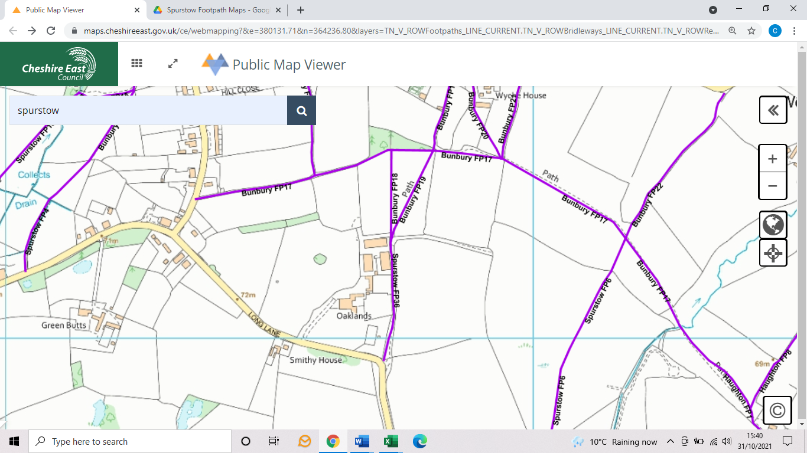
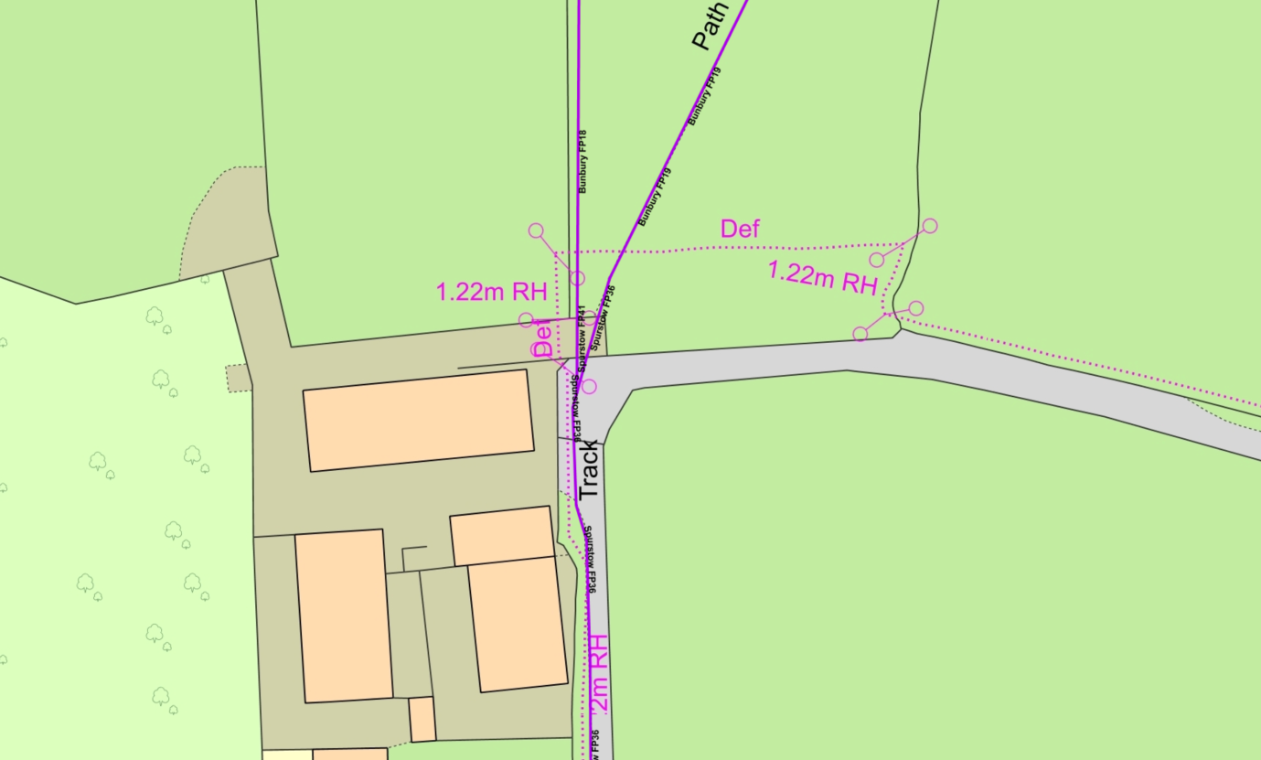

COMMENTS

INSPECTOR |  |  | DATE

