FOOTPATH INSPECTION REPORT
PARISH | Spurstow | FOOTPATH |  | FP5
FROM | Long Lane just North of Spurstow Hall | TO |  | Long Lane near boundary with Haughton
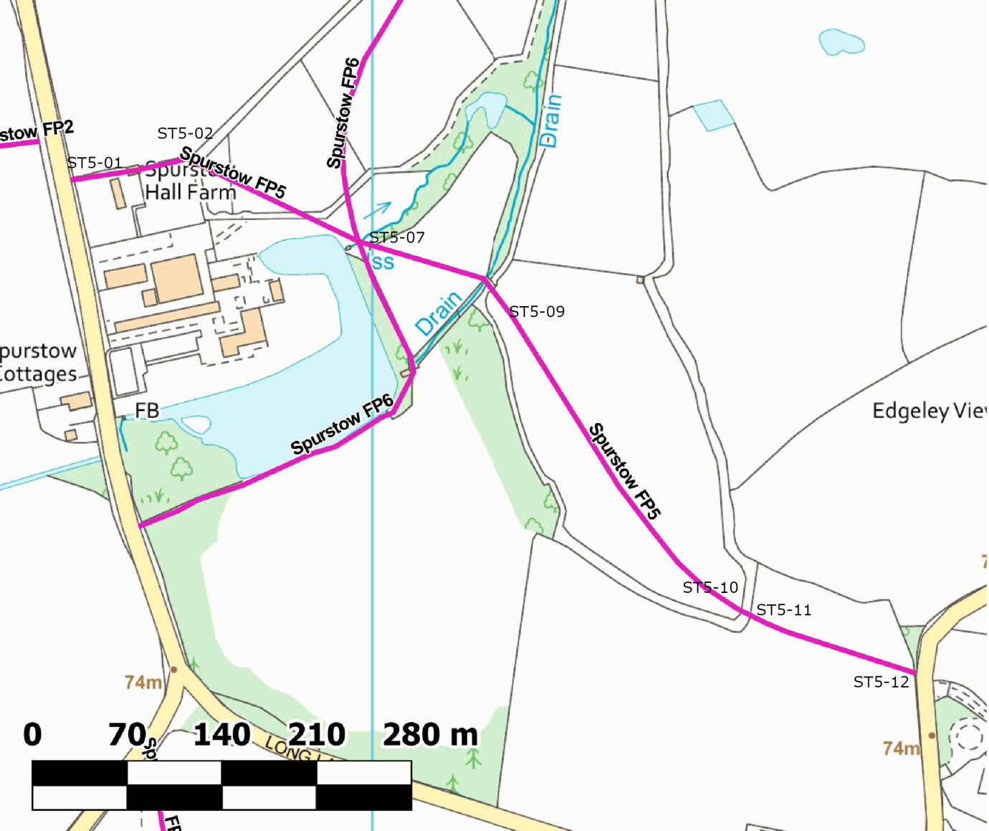

COMMENTS
The footpath starts at a fingerpost and stile next to Spurstow Hall cottage and continues through several small fields, several containing horses. There is an access track following a similar line to the footpath made between the sub-divided paddocks and we followed this track to avoid disturbing the horses as it clearly went to the right place. There were well maintained stiles though several “Beware of the Bull” “Chemical spraying in progress” “Private property keep to the footpaths” and other notices were rather off-putting.
The footpath ends with a fingerpost and stile in good repair.
The footpath has signs of occasional use
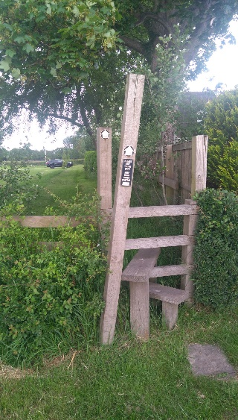 Stile 01 |  |  | 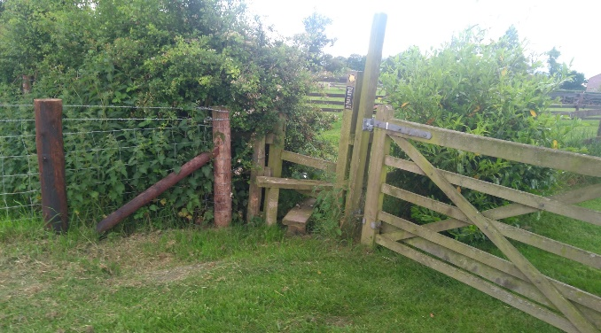Stile 02
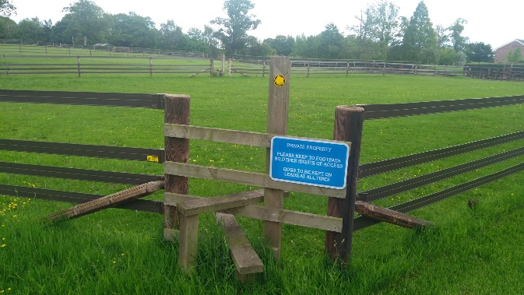  Stile 03 |  |  | 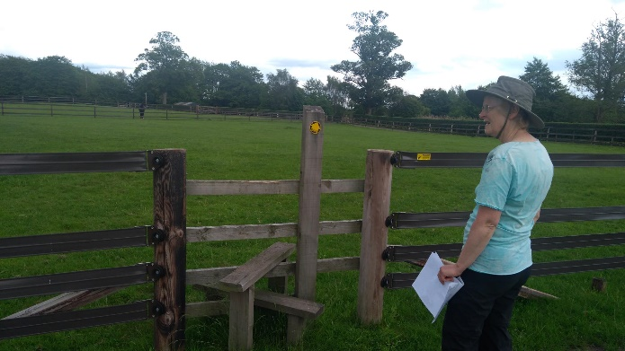Stile 04
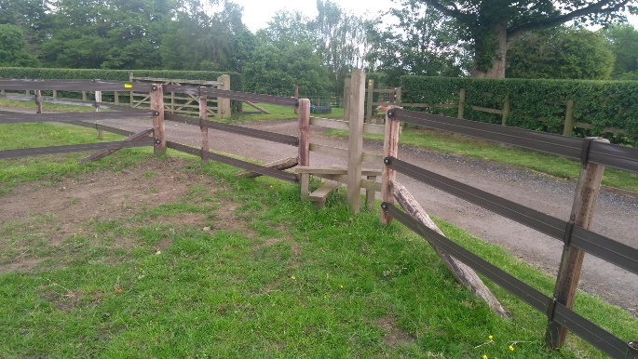Stile 05 |  |  | 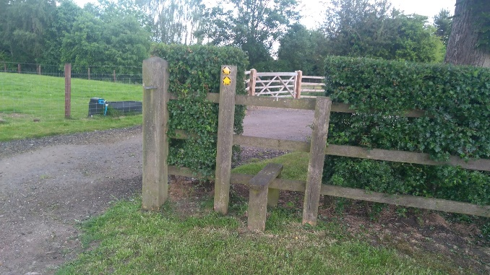Stile 06
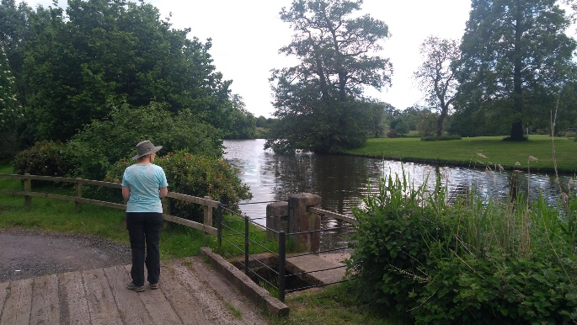Footbridge over stream |  |  | 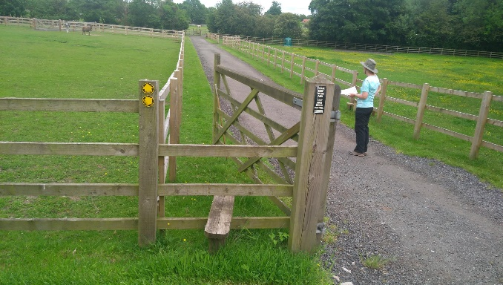  Stile 07
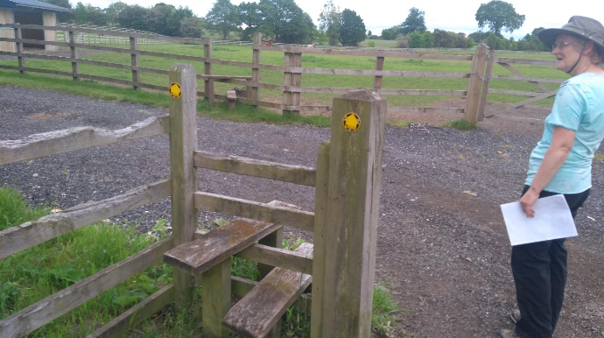Stile 08 |  |  | 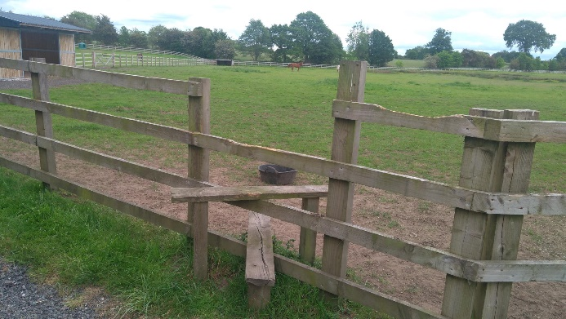Stile 09
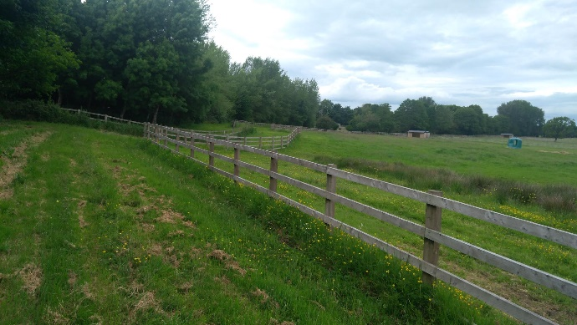Path around horse paddock |  |  | 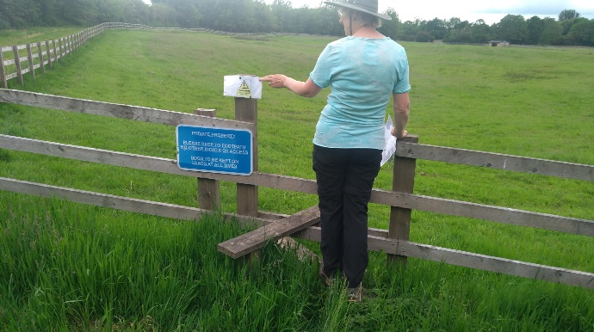Stile 10 – Warning about chemical sprays
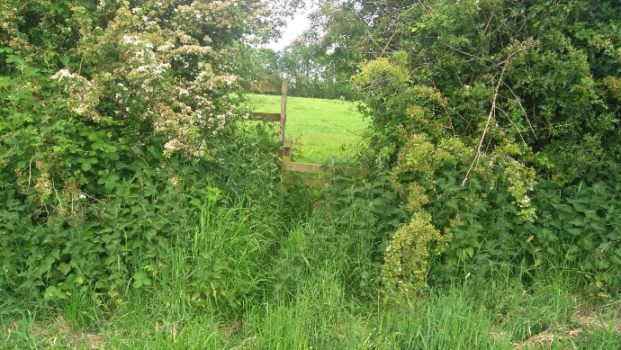Stile 11 |  |  | 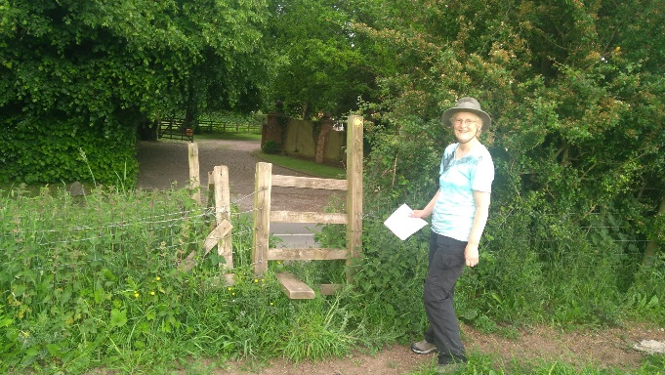Stile 12
INSPECTOR | Katherine Hutchinson |  | DATE | 9 June 2021

