FOOTPATH INSPECTION REPORT
PARISH |  | Spurstow | FOOTPATH |  |  | FP6
FROM |  | North side of Spurstow Hall | TO |  |  | Towards Haughton
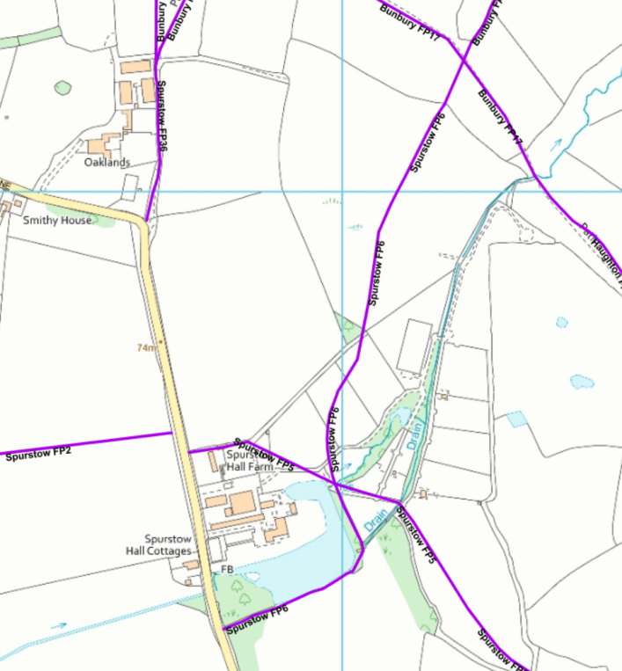
COMMENTS

INSPECTOR |  |  |  | DATE

