FOOTPATH INSPECTION REPORT
PARISH |  | Spurstow | FOOTPATH |  |  | FP7
FROM |  | South of “Cobblestones” on Cappers Lane | TO |  |  | Towards Haughton
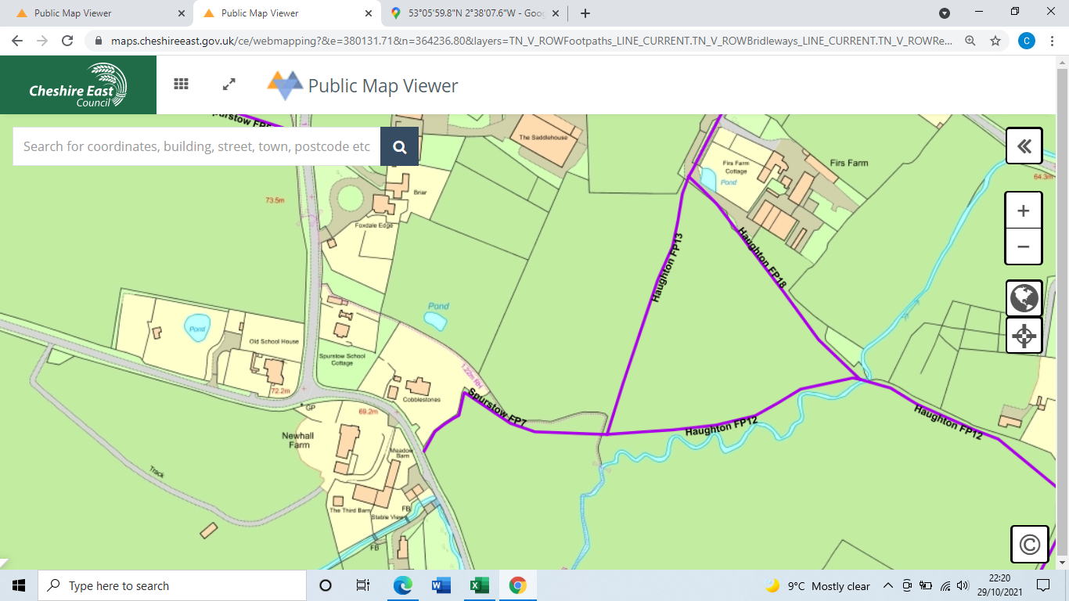
COMMENTS

INSPECTOR |  |  |  | DATE

