FOOTPATH INSPECTION REPORT
PARISH |  | Spurstow | FOOTPATH |  |  | FP8
FROM |  | Opposite Cappers Lane Farm | TO |  |  | West towards Long Lane
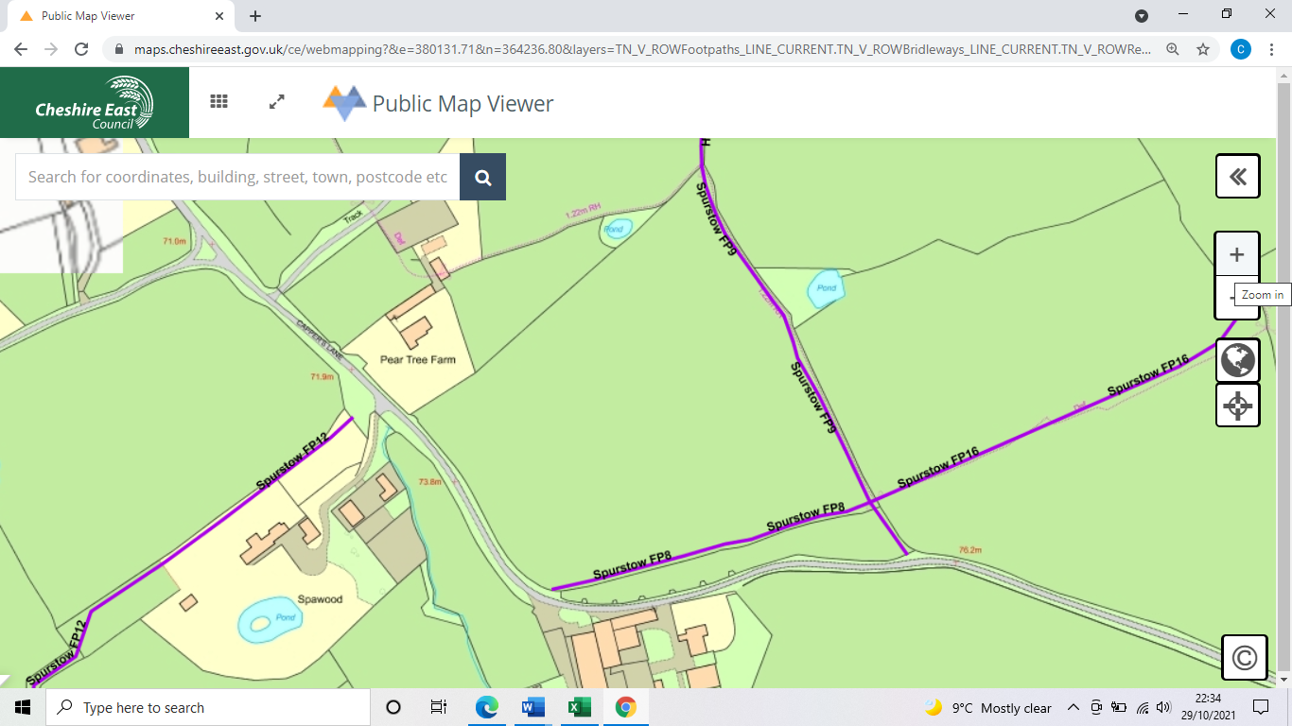
COMMENTS

INSPECTOR |  |  |  | DATE

