FOOTPATH INSPECTION REPORT
PARISH |  | Spurstow | FOOTPATH |  |  | FP9
FROM |  | From Lane Opposite and West of Cappers Lane Farm | TO |  |  | Approx North to towards Long Lane Haughton
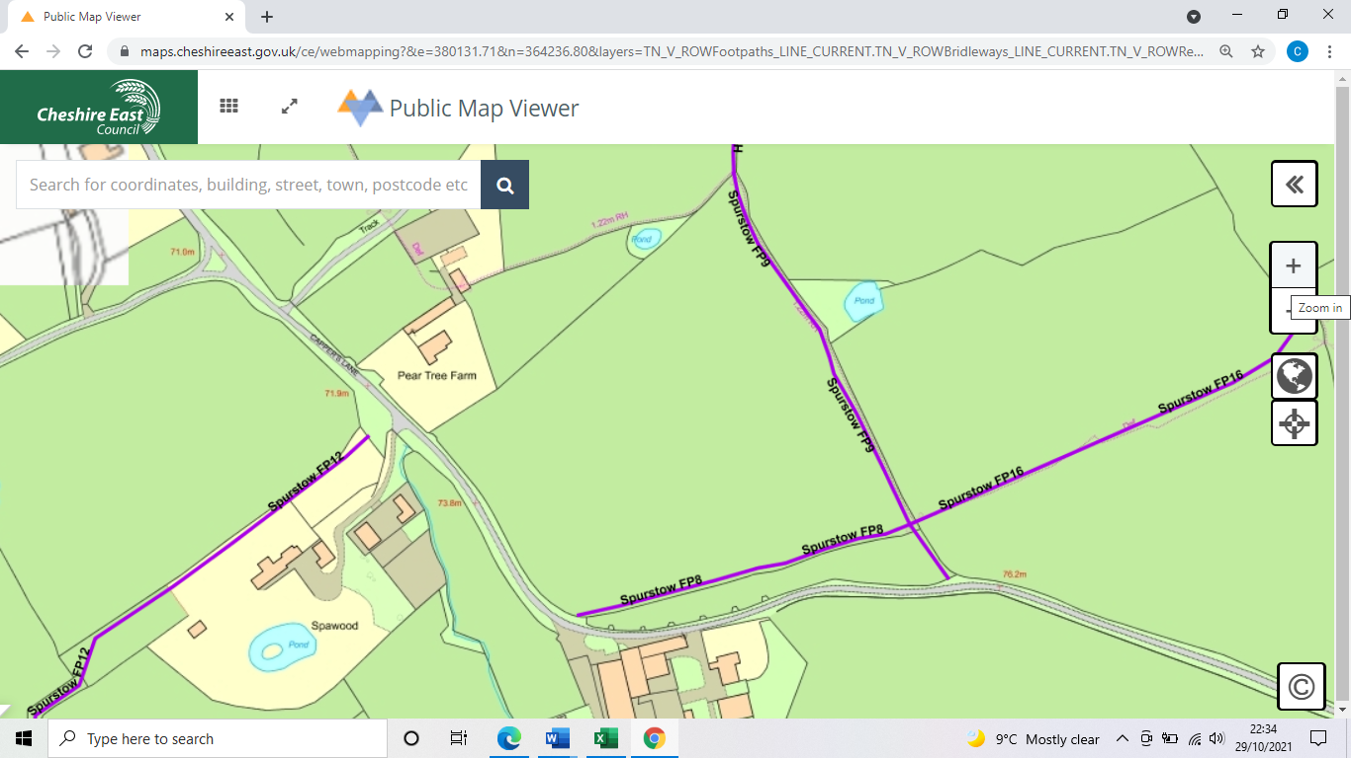
COMMENTS

INSPECTOR |  |  |  | DATE

